

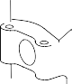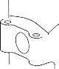

**SAFRAN LANDING SYSTEMS UK Ltd**

CAGE: K0654

PART No. 201587001 AND 201587002 COMPONENT MAINTENANCE MANUAL MAIN LANDING GEAR LEG

DIA. A

**A**

**Z**

**Z**

VIEW **A**

A321-T-32-12-22-142-0

Repair to Main Fitting Figure 601 - Sheet 1

Repair No. 11-37

32-12-22

Page 603

Mar 18/2025



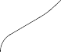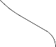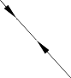

**SAFRAN LANDING SYSTEMS UK Ltd**

CAGE: K0654

PART No. 201587001 AND 201587002 COMPONENT MAINTENANCE MANUAL MAIN LANDING GEAR LEG

DIA. A

1,6

(63)

**B**

**B**

1,6

(63)

DIA. A

SECTION **Z-Z**

(WITHOUT SLEEVES)

4,675mm (0.1841in) MINIMUM WALL THICKNESS TYPICAL

VIEW **B**

TYPICAL

1,6

(63)

**NOTE:**

THE SURFACE FINISH MUST BE

OR BETTER UNLESS GIVEN DIFFERENTLY.

DEBURR THE SHARP EDGES WITH 45 DEGREES CHAMFER OR

0,130 to 0,380mm (0.0051 to 0.0150in) RAD. UNLESS GIVEN DIFFERENTLY.

A321-T-32-12-22-143-0

Repair to Main Fitting Figure 601 - Sheet 2

Repair No. 11-37

32-12-22

Page 604

Mar 18/2025





**SAFRAN LANDING SYSTEMS UK Ltd**

CAGE: K0654

PART No. 201587001 AND 201587002 COMPONENT MAINTENANCE MANUAL MAIN LANDING GEAR LEG

1,6

(63)

1,6

(63)

1,6

(63)

1,6

(63)

REPAIR SLEEVE (62-4505252-00)

4 OFF

01

1,6

(63)

**C**

**C**

1,6

(63)

9,600 to 9,750mm (0.3780 to 0.3838in) DIA. COMMON ZONE

9,600 to 9,750mm (0.3780 to 0.3838in) DIA.

COMMON ZONE

1,000 to 2,000mm (0.0394 to 0.0787in) RAD.

TYPICAL

SECTION **Z-Z**

(WITH SLEEVES)

13,250 to 13,750mm

(0.5217 to 0.5413in) TYPICAL

20,000mm

(0.7874in)

**Y**

**Y**

VIEW **C**

TYPICAL

SECTION **Y-Y**

1,6

(63)

**NOTE:**

THE SURFACE FINISH MUST BE

OR BETTER UNLESS GIVEN DIFFERENTLY.

A321-T-32-12-22-144-0

01

APPLY LOCTITE GRADE 601: REFER TO PCS-5303.

Repair to Main Fitting Figure 601 - Sheet 3

Repair No. 11-37

32-12-22

Page 605

Mar 18/2025

0,200mm (0.0079in) DIA.

0,200mm (0.0079in) DIA.





**SAFRAN LANDING SYSTEMS UK Ltd**

CAGE: K0654

PART No. 201587001 AND 201587002 COMPONENT MAINTENANCE MANUAL MAIN LANDING GEAR LEG

13,500 to 14,000mm (0.5315 to 0.5512in) REF.

1,250 to 1,750mm

(0.0492 to 0.0689in)

x 14,5 to 15,5 DEGREES CHAMFER

02

7,850 to 8,350mm (0.3091 to 0.3287in) DIA. REF.

DIA. Z

02

1,6

(63)

1,6

(63)

**NOTE:**

THE SURFACE FINISH MUST BE

OR BETTER UNLESS GIVEN DIFFERENTLY.

DEBURR THE SHARP EDGES WITH 45 DEGREES CHAMFER OR

0,130 to 0,380mm (0.0051 to 0.0150in) RAD. UNLESS GIVEN DIFFERENTLY.

02 APPLY CADMIUM OR ZINC-NICKEL PLATE. THE CADMIUM PLATE THICKNESS MUST BE BETWEEN 0,010 and 0,015mm (00004 and 00006in).

A321-T-32-12-22-145-0

Repair Sleeve Figure 602

Repair No. 11-37

32-12-22

Page 606

Mar 18/2025



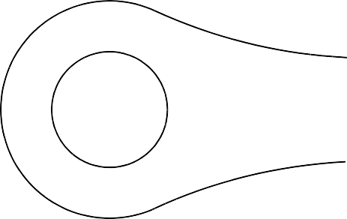

**SAFRAN LANDING SYSTEMS UK Ltd**

CAGE: K0654

PART No. 201587001 AND 201587002 COMPONENT MAINTENANCE MANUAL MAIN LANDING GEAR LEG

350,00mm (13.780in)

Z

Z

1,50mm (0.059in)

x 45 DEGREES CHAMFER (2 PLACES)

2,00 to 3,00mm

(0.079 to 0.118in)

(TYPICAL 4 PLACES)

FACE B

42,50mm (1.673in) MINIMUM

130,60mm (5,142in) MIN

1,00 to 2,00mm

(0.039 to 0.079in) RAD

88,50mm (3.484in) MAXIMUM

4,75 to 5,25mm

(0.187 to 0.207in)

(2 PLACES)

FACE B

0,03mm (0.0012in)

37,50mm (1.476in) RAD

(2 PLACES)

11,65mm

(0.4587in) MIN WALL THICKNESS

Y

0,01mm (0.0004in)

X

Y

DIA A

43,925mm (1.7293in) MAXIMUM

SECTION Z-Z

(WITHOUT BUSHES)

A321A5546-1

Repair to Lower Torque Link - Machining Figure 601

Repair No. 12-1

Page 603 Dec 6/2019

32-12-22

X





**SAFRAN LANDING SYSTEMS UK Ltd**

CAGE: K0654

PART No. 201587001 AND 201587002 COMPONENT MAINTENANCE MANUAL MAIN LANDING GEAR LEG

0,75 to 1,00mm

(0.030 to 0.039in)

RADIUS

1,50mm (0.059in) X 15 DEGREES

CHAMFER

REPAIR BUSH 450258145

0,025mm (0.0010in) DIA

DIA F

0,75 to 1,00mm

(0.030 to 0.039in)

x 30 DEGREES CHAMFER (2 PLACES)

47,950 to 47,975mm

(1.8878 to 1.8887in)

APPLY SEALANT TO PCS-7200

DO NOT PAINT

130,450 to 130,550mm

(5.1359 to 5.1397in)

DO NOT PAINT

REPAIR BUSH 450258145

37,000 to 37,025mm

0,030mm (0.0012in)

(1.4567 to 1.4577in) DIA

CHECK DIA THROUGH

BOTH BUSHES

SECTION Z-Z (WITH BUSHES) REFER TO FIGURE 601

A321A5547-1

Repair Bushes - Machining and Installation Figure 602

Repair No. 12-1

Page 604 Dec 6/2019

32-12-22



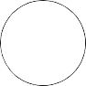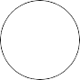

**SAFRAN LANDING SYSTEMS UK Ltd**

CAGE: K0654

PART No. 201587001 AND 201587002 COMPONENT MAINTENANCE MANUAL MAIN LANDING GEAR LEG

350,00mm (13.780in) CRS

**Z**

**Z**

1,50mm (0.059in)

x 45 DEGREES CHAMFER (2 PLACES)

2,00 to 3,00mm

**X**

0,03mm (0.0012in)

(0.079 to 0.118in) RADIUS

(TYPICAL 4 PLACES)

LUG WIDTH E 41,100mm (1.6181in) MINIMUM

FACE B

1,6

(63)

129,75mm

(5.1083in) MIN

1,6

(63)

89,35mm (3.5177in) MAX

4,75 to 5,25mm

(0.187 to 0.207in)

RADIUS (2 PLACES)

FACE C

0,03mm (0.0012in)

37,50mm (1.476in)

(2 PLACES)

11,450mm

(0.4508in)

MIN WALL THICKNESS

**Y**

0,01mm (0.0004in)

**X**

**Y**

DIA A

43,925mm (1.7293in) MAXIMUM

SECTION **Z-Z**

(WITHOUT REPAIR BUSHES)

A321-S-32-12-22-027-0

Repair to Upper Torque Link - Machining Figure 601

Repair No. 12-2

Page 604 Dec 6/2019

32-12-22

1,6

(63)





**SAFRAN LANDING SYSTEMS UK Ltd**

CAGE: K0654

PART No. 201587001 AND 201587002 COMPONENT MAINTENANCE MANUAL MAIN LANDING GEAR LEG

DO NOT CADMIUM PLATE

DO NOT CADMIUM PLATE

FACE G

DO NOT CADMIUM PLATE

0,75 to 1,00mm

(0.030 to 0.039in)

RADIUS

1,50mm (0.059in) X 30 DEGREES INCLUSIVE CHAMFER

REPAIR BUSH

DO NOT CADMIUM PLATE

DIA F

0,025mm (0.0010in) DIA

47,950 to 47,975mm

(1.8878 to 1.8887in)

APPLY SEALANT TO PCS-7200

NO PAINT

NO PAINT

130,450 to 130,550mm

(5.1359 to 5.1397in)

NO PAINT

REPAIR BUSH

NO PAINT

38,000 to 38,025mm

0,030mm (0.0012in)

(1.4961 to 1.4970in) DIA

NO PAINT

CHECK DIA THROUGH

BOTH BUSHES

SECTION Z-Z

(WITH REPAIR BUSHES)

REFER TO FIGURE 601

NO PAINT

A321-S-32-12-22-028-0

Repair Bushes - Machining and Installation Figure 602

32-12-22

Repair No. 12-2

Page 605 Dec 6/2019

1,6

(63)





**SAFRAN LANDING SYSTEMS UK Ltd**

CAGE: K0654

PART No. 201587001 AND 201587002 COMPONENT MAINTENANCE MANUAL MAIN LANDING GEAR LEG

DIA. D

TYPICAL 4 PLACES

1,00mm (0.039in)

X 45 DEGREES CHAMFER 2 PLACES

10,00mm (0.393in) RAD

10,00mm (0.393in) RAD

10,00mm (0.393in)

10,00mm (0.393in)

SIDE ELEVATION WITHOUT SLEEVES

47,625mm (1.875in)

23,813mm (0.9375in)

33,338mm (1.3125in)

4 HOLES

9,75 to 9,85mm (0.384 to 0.388in) DIA.

5 DEGREES

66,675mm

(2.625in)

10,00mm RAD (0.393in)

10,00mm (0.393in)

10,00mm (0.393in) RAD

10,00mm (0.393in)

1,00mm (0.039in)

X 45 DEGREES CHAMFER

2 PLACES WITH SLEEVES FITTED

SIDE ELEVATION WITH SLEEVES FITTED (4 MAX)

15 DEGREES

DIA. H

1,00mm (0.039in)

45mm (1.772in)

6,35mm (0.25in)

Sleeve 440016734

A321-S-32-12-22-030-0

Repair Sleeves - Machining and Installation Figure 603

Repair No. 12-2

Page 606 Dec 6/2019

32-12-22

0,20mm (0.008in) DIA.

**X**

0,20mm (0.008in) DIA.

**X**





**SAFRAN LANDING SYSTEMS UK Ltd**

CAGE: K0654

PART No. 201587001 AND 201587002 COMPONENT MAINTENANCE MANUAL MAIN LANDING GEAR LEG

350,00mm (13.780in)

Z

Z

DIA A

68,13mm (2.682in)

MAXIMUM

0,030mm (0.0012in)

X

W

W

39,00mm (1.535in) MINIMUM LUG WIDTH

1,00 to 2,00mm (0.039 to 0.079in) RADIUS

DIM. E

85,00 (3.346in) SPOTFACE WITH

2,50 to 3,00mm (0.098 to 0.118in) CORNER RADIUS

TYPICAL 2 PLACES

FACE C

132,25mm (5.207in) MAXIMUM

163,16mm (6.423in)

0.040mm (0.0016in)

X

FACE D

MAXIMUM

2,00mm (0.079in)

X 45 DEGREES CHAMFER

TYPICAL 2 PLACES

39,00mm (1.535in) MINIMUM

LUG WIDTH

DIM. F

1,00 to 2,00mm (0.039 to 0.079in) RADIUS

SECTION Z-Z

WITHOUT BUSHES

21,35mm (0.841in)

MINIMUM WALL

THICKNESS TYPICAL 2 PLACES

DIA B

X

68,13mm (2.682in) MAXIMUM

A321A6394-3

Repair to Upper Torque Link - Machining Figure 601

Repair No. 12-3

Page 603 Dec 6/2019

32-12-22

0.040mm (0.0016in)

W





**SAFRAN LANDING SYSTEMS UK Ltd**

CAGE: K0654

PART No. 201587001 AND 201587002 COMPONENT MAINTENANCE MANUAL MAIN LANDING GEAR LEG

U

0,95 to 1,45mm

(0.037 to 0.057in)

RADIUS

DIM. H

1,50mm (0.059in) X 30 DEGREES

CHAMFER

DIA G

REPAIR BUSH 450258806

60,00 to 60,03mm (2.362 to 2.363in) DIA.

V

REPAIR BUSH 450258806

155,000 to 155,063mm

(6.1024 to 6.1048in)

130,45 to 130,55mm

(5.136 to 5.140in)

0,75 to 1,00mm (0.029 to 0.039in) X 60 DEGREES CHAMFER

(BOTH BUSHES)

SECTION Z-Z

WITH BUSHES INSTALLED

REPAIR BUSH 450258806

APPLY SEALANT TO PCS-7200

(BOTH BUSHES)

A321A6395-1

Repair Bushes - Machining and Installation Figure 602

Repair No. 12-3

Page 604 Dec 6/2019

32-12-22

0,040mm (0.0016in)

V

0,025mm (0.0010in) DIA

U



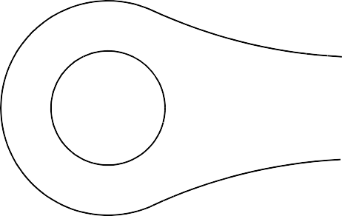

**SAFRAN LANDING SYSTEMS UK Ltd**

CAGE: K0654

PART No. 201587001 AND 201587002 COMPONENT MAINTENANCE MANUAL MAIN LANDING GEAR LEG

350,00mm (13.780in)

Z

Z

DIA B

68,13mm (2.682in)

MAXIMUM

0,030mm (0.0012in)

39,00mm (1.535in) MINIMUM LUG WIDTH

X

W

W

DIM. E

85,00 (3.346in) SPOTFACE WITH

2,50 to 3,00mm (0.098 to 0.118in) CORNER RADIUS

TYPICAL 2 PLACES

FACE D

132,25mm (5.207in) MAXIMUM

163,16mm (6.423in) MAXIMUM

FACE C

2,00mm (0.079in)

X 45 DEGREES CHAMFER

TYPICAL 2 PLACES

39,00mm (1.535in) MINIMUM

LUG WIDTH

DIM. F

SECTION Z-Z

WITHOUT BUSHES

1,00 to 2,00mm

(0.039 to 0.079in) RADIUS

TYPICAL 2 PLACES

21,35mm (0.841in)

MINIMUM WALL

THICKNESS TYPICAL 2 PLACES

DIA A

X

68,13mm (2.682in) MAXIMUM

A321A6400-1

Repair to Lower Torque Link - Machining Figure 601

Repair No. 12-4

Page 603 Dec 6/2019

32-12-22

0.040mm (0.0016in)

X

0.040mm (0.0016in)

W





**SAFRAN LANDING SYSTEMS UK Ltd**

CAGE: K0654

PART No. 201587001 AND 201587002 COMPONENT MAINTENANCE MANUAL MAIN LANDING GEAR LEG

U

0,95 to 1,45mm

(0.037 to 0.057in)

RADIUS

DIM. H

1,50mm (0.059in) X 30 DEGREES

CHAMFER

DIA G

REPAIR BUSH 450258806

60,00 to 60,03mm (2.362 to 2.363in) DIA.

V

REPAIR BUSH 450258806

155,000 to 155,063mm

(6.1024 to 6.1048in)

130,45 to 130,55mm

(5.136 to 5.140in)

0,75 to 1,00mm (0.029 to 0.039in) X 60 DEGREES CHAMFER

(BOTH BUSHES)

REPAIR BUSH 450258806

APPLY SEALANT TO PCS-7200

(BOTH BUSHES)

A321A6401-1

Repair Bush - Machining and Installation Figure 602

Repair No. 12-4

Page 604 Dec 6/2019

32-12-22

0,040mm (0.0016in)

V

0,025mm (0.0010in) DIA

U





**SAFRAN LANDING SYSTEMS UK Ltd**

CAGE: K0654

PART No. 201587001 AND 201587002 COMPONENT MAINTENANCE MANUAL MAIN LANDING GEAR LEG

350,000mm

(13.7795in)

Z

3,90mm (0.154in) MINIMUM WALL SECTION

4 PLACES

33,338mm

(1.3125in)

66,675mm

(2.6250in)

5 DEGREES

42,000mm (1.6535in) DIA.

REF.

Z

23,813mm (0.9375in)

47,625mm (1.875in)

Y

1,6

(63)

DIA. A

11,400 to 11,500mm

(0.4488 to 0.4527in)

4 PLACES

SECTION Z-Z

(WITHOUT SLEEVES)

A321-S-32-12-22-047-0

Repair to Upper Torque Link - Machining Figure 601

32-12-22

Repair No. 12-5

Page 603 Dec 6/2019

0,20mm (0.008in) DIA.

Y





**SAFRAN LANDING SYSTEMS UK Ltd**

CAGE: K0654

PART No. 201587001 AND 201587002 COMPONENT MAINTENANCE MANUAL MAIN LANDING GEAR LEG

1,00mm (0.039in)

x 15 DEGREES CHAMFER

DIA. B

6,35mm (0.25in) NO CADMIUM PLATE

FACE C

45,000mm (1.7717in)

REPAIR SLEEVE 450266526

42,90 to 43,10mm (1.689 to 1.697in) REF.

1,6

(63)

9,750 to 9,850mm

(0.3839 to 0.3878in)

MAXIMUM 4 PLACES

REPAIR SLEEVES 450266526

MAX 4 PLACES

ASSEMBLE SLEEVES

FLUSH TO THIS FACE

FINISH SLEEVE FLUSH TO THIS

FACE

2,00mm (0.079in) RAD. REF.

2 PLACES

FACE D

FINISH SLEEVE FLUSH TO THIS

FACE

1,00mm (0.039in)

x 45 DEGREES CHAMFER MAXIMUM

2 PLACES

3,75mm (0.1476in)

2 PLACES REF.

SECTION Z-Z (WITH SLEEVES)

A321-S-32-12-22-048-0

Repair Sleeves - Machining and Installation Figure 602

32-12-22

Repair No. 12-5

Page 604 Dec 6/2019

0,20mm (0.008in) DIA.

Y



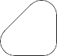

**SAFRAN LANDING SYSTEMS UK Ltd**

CAGE: K0654

PART No. 201587001 AND 201587002 COMPONENT MAINTENANCE MANUAL MAIN LANDING GEAR LEG

Z

335,00mm (13.189in)

Z

26,75 to 27,25mm

(1.053 to 1.073in) DIA. PRIMER ONLY

60,00mm (2.362in)

REF.

DIA. B 21,921mm (0.8630in) MAXIMUM.

1,00mm (0.039in)

X 45 DEGREES CHAMFER 2 PLACES. PRIMER ONLY

DIA. A

21,921mm (0.8630in) MAXIMUM.

PRIMER ONLY

PRIMER ONLY

3,75mm (0.1476in) PRIMER ONLY

FACE C

MINIMUM WALL THICKNESS

2 PLACES

FACE D

LUG E

6,90mm (0.272in) MINIMUM

LUG F

LUG THICKNESS

6,90mm (0.272in) MINIMUM LUG THICKNESS

SECTION Z-Z

(WITHOUT BUSHES)

A321-S-32-12-22-005-0

Repair to Upper Slave Link - Machining Figure 601

Repair No. 13-1

Page 604 Dec 6/2019

32-12-22





**SAFRAN LANDING SYSTEMS UK Ltd**

CAGE: K0654

PART No. 201587001 AND 201587002 COMPONENT MAINTENANCE MANUAL MAIN LANDING GEAR LEG

38,0mm (1.50in) DIA. SPOTFACE CUTTER WITH CORNER RADIUS

1,20mm (0.047in) 2 OUTER FACES

18,00mm (0.709in) REF.

125,0mm (5.00in) DIA. SPOTFACE CUTTER WITH CORNER RADIUS 3,00mm (0.118in)

2 INNER FACES

A321-S-32-12-22-017-0

Repair to Upper Slave Link - Machining Figure 602

Repair No. 13-1

Page 605 Dec 6/2019

32-12-22





**SAFRAN LANDING SYSTEMS UK Ltd**

CAGE: K0654

PART No. 201587001 AND 201587002 COMPONENT MAINTENANCE MANUAL MAIN LANDING GEAR LEG

DIM. J

DIM. K

FACE L

FACE M

0,30 to 0,70mm

(0.012 to 0.028in) RAD.

0,80 to 1,00mm

(0.031 to 0.039in) RAD.

0,05mm (0.002in) DIA.

0,025mm (0.001in) DIA.

**Y**

**X**

**X**

**Y**

DO NOT CADMIUM

PLATE

DO NOT CADMIUM

PLATE

DIA. G

DIA. H

1,6

(63)

1,6

(63)

1,00mm (0.039in) x 15 DEGREES

0,50mm (0.020in) x 15 DEGREES

CHAMFER

CHAMFER

REPAIR BUSH 450217818

REPAIR BUSH 450217819

REPAIR BUSH 450217818

REPAIR BUSH 450217819

12,700 to 12,727mm

(0.5000 to 0.5010in) DIA. CHECK DIA. THRU

17,500 to 17,527mm (0.6890 to 0.6900in) DIA. CHECK DIA. THRU

APPLY SEALANT TO PCS-7200

4 PLACES

9,350 to 9,650mm

(0.3680 to 0.3799in)

10,000 to 10,100mm

(0.3937 to 0.3976in)

SECTION **Z-Z**

(WITH BUSHES)

A321-S-32-12-22-006-1

Repair Bushes - Machining and Installation Figure 603

Repair No. 13-1

Page 606 Dec 9/2022

32-12-22

3,2

(125)

1,6

(63)





**SAFRAN LANDING SYSTEMS UK Ltd**

CAGE: K0654

PART No. 201587001 AND 201587002 COMPONENT MAINTENANCE MANUAL MAIN LANDING GEAR LEG

5,50mm (0.2165in) MINIMUM WALL

THICKNESS BOTH SIDES

335,00mm (13.189in)

CRS

FACE B

Z

0,010mm (0.0004in)

Z

DIA. A

FACE B

LUG WIDTH D 14,62mm (0.575in) MINIMUM

130,25 to 130,40mm

(5.128 to 5.134in)

1,00mm (0.040in)

X 45 DEGREES

CHAMFER TYPICAL

4 PLACES

FACE B

Y

DIA. A

FACE B

26,75 to 27,25mm

(1.053 to 1.073in) DIA. PRIMER PAINT 4 PLACES

LUG WIDTH D 14,62mm (0.575in) MINIMUM

A321-S-32-12-22-009-0

Repair to Upper Slave Link - Machining Figure 601

Repair No. 13-2

Page 603 Dec 6/2019

32-12-22

0,010mm (0.0004in)

Y





**SAFRAN LANDING SYSTEMS UK Ltd**

CAGE: K0654

PART No. 201587001 AND 201587002 COMPONENT MAINTENANCE MANUAL MAIN LANDING GEAR LEG

16,006 to 16,033mm

(0.6302 to 0.6312in)

DIAMETER REF. THRU 4 BUSHES

APPLY SEALANT TO PCS-7200

127,25 to 127,65mm

(5.010 to 5.025in) REF.

OVERSIZE BUSH (REFER TO TABLE 601) 4 OFF

APPLY SEALANT TO PCS-7200

162,19 to 163,65mm

(6.385 to 6.443in) REF.

A321-S-32-12-22-010-1

Oversize Bushes - Installation Figure 602

Repair No. 13-2

Page 604 Dec 6/2019

32-12-22



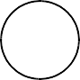

**SAFRAN LANDING SYSTEMS UK Ltd**

CAGE: K0654

PART No. 201587001 AND 201587002 COMPONENT MAINTENANCE MANUAL MAIN LANDING GEAR LEG

**Z**

**Z**

0,02mm (0.0008in) DIA.

1,00 to 2,00mm (0.039 to 0.079in) RAD.

1,00 to 2,00mm (0.039 to 0.079in) RAD.

DIA. A 53,13mm (2.0917in) MAXIMUM

SECTION **Z-Z**

(WITHOUT BUSH)

A321-S-32-12-22-097-0

Repair to Upper Diaphragm Tube - Machining Figure 601

32-12-22

Repair No. 14-1

Page 603 Jun 23/2017



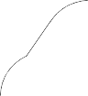

**SAFRAN LANDING SYSTEMS UK Ltd**

CAGE: K0654

PART No. 201587001 AND 201587002 COMPONENT MAINTENANCE MANUAL MAIN LANDING GEAR LEG

**X**

THIS BORE TO

BE CADMIUM PLATED

0,02mm

APPLY SEALANT TO PCS-7200

(0.0008in) DIA.

0,10mm (0.039in)

**X**

REPAIR BUSH

**Y**

**Y**

SECTION **Y-Y**

(WITH BUSH)

15,30 to 15,40mm

(0.602 to 0.606in) DEPTH OF SLOT

46,000 to 46,039mm (1.8110 to 1.8126in) DIA.

0,02mm

**W**

**W**

(0.0008in) DIA.

SECTION **Z-Z**

(WITH BUSH) REFER TO FIGURE 601

**V**

0,500mm (0.0197in) X 45 DEGREES CHAMFER

DIA. B

REPAIR BUSH

0,020mm (0.0008in)

**V**

A321A5904-1

Repair Bush - Machining and Installation Figure 602

Repair No. 14-1

Page 604 Jun 23/2017

32-12-22





**SAFRAN LANDING SYSTEMS UK Ltd**

CAGE: K0654

PART No. 201587001 AND 201587002 COMPONENT MAINTENANCE MANUAL MAIN LANDING GEAR LEG

Z

Z

T

DIA A

0,10mm (0.0039in)

0,02mm

0,02mm (0.0008in) DIA

FACE

B

(0.008in)

83,80mm

(3.2992in) MIN

Y

SECTION Z-Z

(WITOUT REPAIR BUSH)

124,50mm (4.9016in) REF

53,50 to 54,50mm

(2.106 to 2.146in)

0,20 to 0,40mm

(0.008 to 0.016in) RAD

SPOTFACE WITH

5,00 to 6,00mm

0,40mm (0.016in) DIA

T

(0.197 to 0.236in) CORNER RAD

7,80mm (0.3071in)

MIN WALL THICKNESS

1,20mm (0.047in)

x 45 DEGREES CHAMFER

DETAIL Y

DIAMETER A

37,20mm (1.465in)

0,40 to 1,00mm

(0.016 to 0.039in)

RAD

MAXIMUM

A321A5905-1

Repair to Upper Diaphragm Tube - Machining Figure 601

Repair No. 14-2

Page 603 May 31/2019

32-12-22



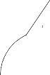

**SAFRAN LANDING SYSTEMS UK Ltd**

CAGE: K0654

PART No. 201587001 AND 201587002 COMPONENT MAINTENANCE MANUAL MAIN LANDING GEAR LEG

T

0,65 to 0,95mm

(0.0256 to 0.0374in) RADIUS

FACE D

0,50mm (0.0197in)

X 45 DEGREES CHAMFER

0,020mm (0.0008in)

T

DIA C

REPAIR BUSH

THIS BORE TO BE CADMIUM

PLATED

V

31,050 to 31,075mm (1.2224 to 1.2234in) DIA

0,020mm (0.0008in)

SECTION X-X

0,100mm (0.0039in)

W

U

REPAIR BUSH 450266286

APPLY SEALANT TO PCS-7200

0,100mm (0.0039in)

W

V

W

0,05mm (0.0020in)

U

88,45mm (3.4823in)

X

X

SECTION Z-Z

(WITH REPAIR BUSH)

A321A5906-1

Repair Bush - Machining and Installation Figure 602

Repair No. 14-2

Page 604 May 31/2019

32-12-22

0,020mm (0.0008in) DIA

V

0,020mm (0.0008in)

T





**SAFRAN LANDING SYSTEMS UK Ltd**

CAGE: K0654

PART No. 201587001 AND 201587002 COMPONENT MAINTENANCE MANUAL MAIN LANDING GEAR LEG

Z

DO NOT MACHINE THIS FACE

36,50mm (1.437in) MAXIMUM

30,00mm (1.181in) MINIMUM

FACE E

FACE F

26,00mm (1.024in) MAXIMUM

UPPER SEAL GROOVE

10,00mm (0.394in)

MINIMUM

0,15 to 0,25mm

(0.006 to 0.010in)

RADIUS

SULPHAMATE NICKEL MUST NOT ENTER RADIUS

0,15 to 0,25mm

(0.006 to 0.010in) RADIUS

DIA A 175,84mm (6.923in) MINIMUM

DIA B

169,85mm (6.687in) MINIMUM

0,25 to 0,63mm

(0.010 to 0.025in) RADIUS

0,51 to 0,89mm

(0.020 to 0.035in) RADIUS

DIA C

181,89mm (7.161in) MINIMUM

FACE G

FACE H

MAIN SEAL GROOVE

DETAIL Z

(BEFORE APPLYING SULPHAMATE NICKEL PLATE)

A321A7127-1

Repair to Upper Diaphragm Tube Figure 601

32-12-22

Repair No. 14-3

Page 604 Dec 6/2019





**SAFRAN LANDING SYSTEMS UK Ltd**

CAGE: K0654

PART No. 201587001 AND 201587002 COMPONENT MAINTENANCE MANUAL MAIN LANDING GEAR LEG

35,75 to 36,25mm (1.407 to 1.427in)

0,30mm (0.012in) DIA

Y

Y

V

25,25 to 25,75mm

(0.994 to 1.014in)

W

U

171,307 to 171,370mm

(6.7444 to 6.7468in)

DETAIL Z

(AFTER APPLYING SULPHAMATE NICKEL PLATE)

177,300 to 177,363mm (6.9803 to 6.9828in) DIA.

183,374 to 183,410mm

14,71 to 14,96mm

(0.579 to 0.589in)

(7.2195 to 7.2209in) DIA.

REF.

5,400 to 5,500mm

(0.2126 to 0.2165in)

0 to 0.5

0 to 0.5 DEGREES

DEGREES

REF.

0,15 to 0,25mm

(0.006 to 0.010in)

0 to 0.5 DEGREES

0 to 0.5 DEGREES

0,04mm (0.0016in) DIA

W

RADIUS

0,15 to 0,25mm

(0.006 to 0.010in) RADIUS

0,51 to 0,89mm

(0.020 to 0.035in) RADIUS

0,25 to 0,63mm (0.010 to 0.025in) RADIUS

DETAIL V

UPPER SEAL GROOVE

DETAIL U

MAIN SEAL GROOVE

A321A7128-1

Repair to Upper Diaphragm Tube Figure 602

Repair No. 14-3

Page 605 Dec 6/2019

32-12-22

0,04mm (0.0016in) DIA

W





**SAFRAN LANDING SYSTEMS UK Ltd**

CAGE: K0654

PART No. 201587001 AND 201587002 COMPONENT MAINTENANCE MANUAL MAIN LANDING GEAR LEG

**A**

DO NOT MACHINE THIS FACE

37,510mm (1.4768in) MAX.

FACE E

31,710mm (1.2484in) MIN.

FACE F

26,010mm (1.0240in) MAX.

FACE H

FACE G

MAIN SEAL GROOVE

10,280mm (0.4047in) MIN.

0,150 to 0,250mm (0.0059 to 0.0098in) RAD. 0,510 to 0,890mm

(0.0201 to 0.0350in) RAD.

UPPER SEAL GROOVE

0,150 to 0,250mm

(0.0059 to 0.0098in) RAD.

0,250 to 0,630mm (0.0098 to 0.0248in) RAD.

1,000 to 2,000mm (0.0394 to 0.0787in) RAD.

1,000 to 2,000mm (0.0394 to 0.0787in) RAD.

CADMIUM PLATE AND SULPHAMATE NICKEL MUST NOT ENTER RADIUS

DIA. C 181,890mm (7.1610in) DIA.

MIN .

DIA. B

169,850mm (6.6870in) DIA. MIN .

DIA. A

175,841mm

(6.9229in) DIA.

DETAIL **A**

(BEFORE APPLYING SULPHAMATE NICKEL PLATE)

MIN .

1,6

(63)

**NOTE:**

THE SURFACE FINISH MUST BE

A321-T-32-12-22-149-0

OR BETTER UNLESS GIVEN DIFFERENTLY.

Repair to Upper Diaphragm Tube Figure 601 - Sheet 1

32-12-22

Repair No. 14-4

Page 605 Mar 18/2025





**SAFRAN LANDING SYSTEMS UK Ltd**

CAGE: K0654

PART No. 201587001 AND 201587002 COMPONENT MAINTENANCE MANUAL MAIN LANDING GEAR LEG

36,750 to 37,250mm (1.4469 to 1.4665in)

25,250 to 25,750mm (0.9941 to 1.0138in)

10,290 to 11,040mm (0.4051 to 0.4346in)

14,710 to 14,960mm (0.5791 to 0.5890in) MAIN SEAL GROOVE

4,780 to 5,030mm

(0.1882 to 0.1980in) UPPER SEAL GROOVE

**C**

**B**

**A**

DIA. C 183,374 to 183,410mm (7.2194 to 7.2209in) DIA.

192,500 to 192,750mm (7.5787 to 7.5886in) DIA.

DIA. B

171,307 to 171,370mm (6.7444 to 6.7469in) DIA.

DIA. A 177,298 to 177,361mm (6.9802 to 6.9827in) DIA.

DETAIL **A**

(AFTER APPLYING SULPHAMATE NICKEL PLATE)

0 to 0,5 DEGR

0 to 0,5 DEGREES

0,150 to 0,250mm

(0.0059 to 0.0098in) RAD. REF.

0,250 to 0,630mm

(0.0098 to 0.0248in) RAD. REF.

DETAIL **B**

0 to 0,5 D

0 to 0,5 DEGREES

0,150 to 0,250 mm (0.0059 to 0.0098in) RAD. REF.

0,510 to 0,890mm (0.0201 to 0.0350in) RAD. REF.

DETAIL **C**

OR BETTER UNLESS GIVEN DIFFERENTLY.

1,6

(63)

**NOTE:**

THE SURFACE FINISH MUST BE

A321-T-32-12-22-150-0

THE THICKNESS OF THE SULPHAMATE NICKEL PLATING AFTER MACHINING MUST BE BETWEEN 0,050 and 0,760mm (0.0020 and 0.0299in).

Repair to Upper Diaphragm Tube Figure 601 - Sheet 2

Repair No. 14-4

Page 606 Mar 18/2025

32-12-22

EGREES

EES

0,040mm (0.0016in) DIA.

**A**

0,040mm (0.0016in) DIA.

**A**

0,300mm (0.0118in) DIA.

**A**





**SAFRAN LANDING SYSTEMS UK Ltd**

CAGE: K0654

PART No. 201587001 AND 201587002 COMPONENT MAINTENANCE MANUAL MAIN LANDING GEAR LEG

22,00mm (0.866in)

REF.

Z

Z

13,50mm (0.531in) REF.

SPOTFACE WITH ALOCROM TO PCS-2220 APPLIED

Y

DIA. A

14,418mm (0.5676in) MAXIMUM

0,025mm (0.0001in)

Y

DIA

1,00mm (0.039in)

X 45 DEGREES CHAMFER

SECTION Z-Z

(WITHOUT REPAIR BEARING)

A321A5865-1

Repair to Bracket - Machining Figure 601

Repair No. 15-1

Page 603 Dec 6/2019

32-12-22





**SAFRAN LANDING SYSTEMS UK Ltd**

CAGE: K0654

PART No. 201587001 AND 201587002 COMPONENT MAINTENANCE MANUAL MAIN LANDING GEAR LEG

0,50 to 0,75mm

(0.020 to 0.030in)

X 15DEGREES CHAMFER

X

DIA. C

0,25 to 0,75mm

(0.010 to 0.030in) RADIUS

REPAIR BEARING

6,300 to 6,550mm

(0.2480 to 0.2579in) REF.

REPAIR BEARING

450266098

9,600 to 9,615mm

(0.3780 to 0.3785in) DIAMETER

APPLY SEALANT TO PCS-7200

SECTION Z-Z

(WITH REPAIR BEARING)

A321A5866-1

Repair Bearing - Machining and Installation Figure 602

Repair No. 15-1

Page 604 Dec 6/2019

32-12-22

DIA 0,025mm

(0.001in)

X





**SAFRAN LANDING SYSTEMS UK Ltd**

CAGE: K0654

PART No. 201587001 AND 201587002 COMPONENT MAINTENANCE MANUAL MAIN LANDING GEAR LEG

22,00mm (0.866in)

REF.

Z

Z

13,50mm (0.531in) REF.

DO NOT PAINT LOCALLY ANODISE TO PCS-2220

3,2

(127)

1,00mm (0.039in) x 90 DEGREES

INCLUSIVE CHAMFER

Y

DIA. A

APPLY LIGHT COAT OF PRIMER

1,6

(63)

SECTION Z-Z

(WITHOUT BEARING)

A321-S-32-12-22-045-0

Repair to Bracket - Machining Figure 601

32-12-22

Repair No. 15-2

Page 603 Dec 6/2019

0,025mm (0.0010in) DIA.

Y





**SAFRAN LANDING SYSTEMS UK Ltd**

CAGE: K0654

PART No. 201587001 AND 201587002 COMPONENT MAINTENANCE MANUAL MAIN LANDING GEAR LEG

1,6

(63)

0,50 to 0,75mm

(0.020 to 0.030in)

X 30 DEGREES INCLUSIVE CHAMFER

X

1,6

(63)

DIA. C

DO NOT CADMIUM PLATE

0,25 to 0,75mm

(0.010 to 0.030in) RADIUS

REPAIR BEARING 450266097

APPLY SEALANT TO

PCS-7200, TYPE 2

13,000 to 13,018mm (0.5118 to 0.5125in) DIA. CHECK DIAMETER

1,6

(63)

REPAIR BEARING

450266097

SECTION Z-Z

(WITH BEARING)

A321-S-32-12-22-046-0

Repair Bearing - Machining and Installation Figure 602

Repair No. 15-2

Page 604 Dec 6/2019

32-12-22

0,025mm (0.0010in) DIA.

X





**SAFRAN LANDING SYSTEMS UK Ltd**

CAGE: K0654

PART No. 201587001 AND 201587002 COMPONENT MAINTENANCE MANUAL MAIN LANDING GEAR LEG

Z

15 DEGREES

Z

22,00mm (0.866in) REF.

Y

1,20mm (0.047in)

X 45 DEGREES CHAMFER

1,20mm (0.047in) X 45 DEGREES CHAMFER

1,6

(63)

1,6

(63)

DIA. A 21,721mm (0.8552in) MAXIMUM

DIA. B 21,721mm (0.8552in) MAXIMUM

0,05mm (0.002in)

0,05mm (0.002in)

Y

Y

SECTION Z-Z

(WITHOUT REPAIR BUSHES)

A321-S-32-12-22-011-0

Repair to Bracket - Machining Figure 601

Repair No. 16-1

Page 603 Dec 6/2019

32-12-22

108,50mm

(4.272in) REF.

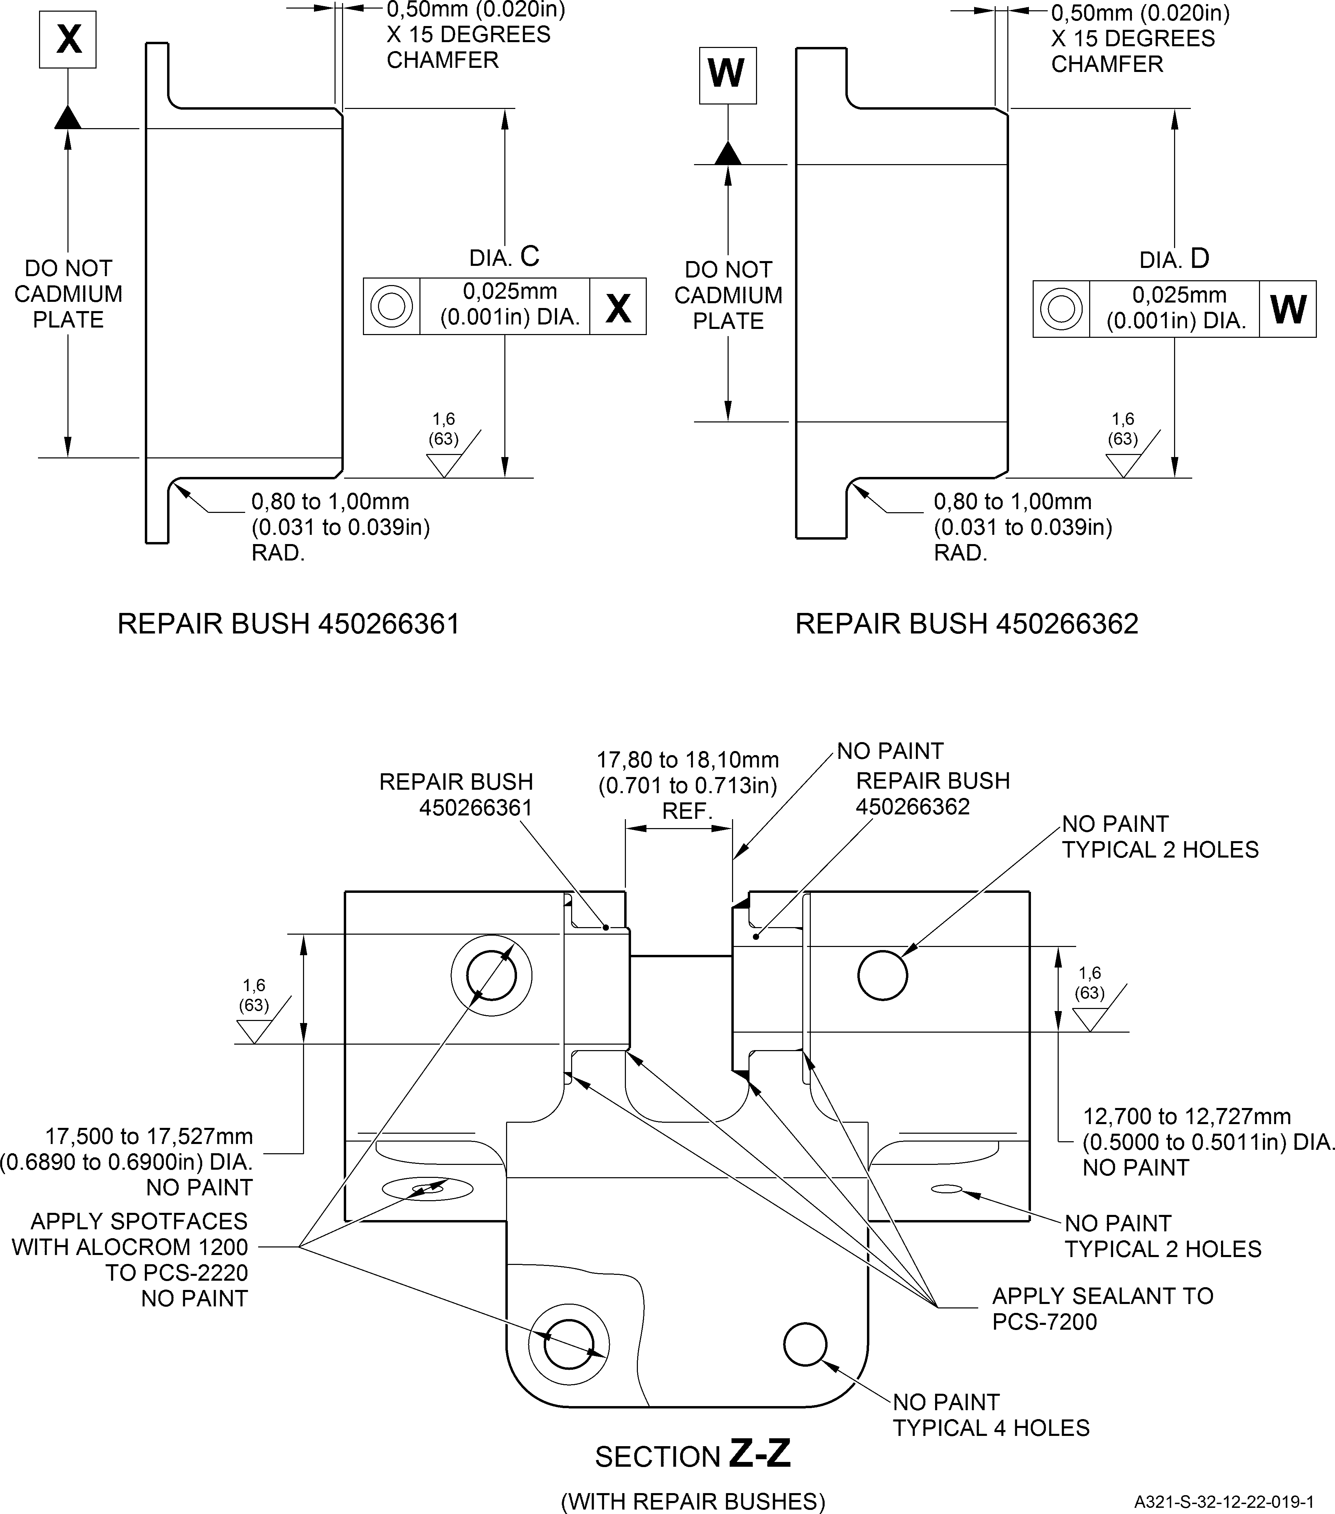

**SAFRAN LANDING SYSTEMS UK Ltd**

CAGE: K0654

PART No. 201587001 AND 201587002 COMPONENT MAINTENANCE MANUAL MAIN LANDING GEAR LEG

Repair Bushes - Machining and Installation Figure 602

Repair No. 16-1

Page 604 Mar 20/2020

32-12-22





**SAFRAN LANDING SYSTEMS UK Ltd**

CAGE: K0654

PART No. 201587001 AND 201587002 COMPONENT MAINTENANCE MANUAL MAIN LANDING GEAR LEG

Z

Z

18,60mm (0.732in) REF.

22,10mm (0.870in) REF.

DIA. A

REFER TO TABLE 601

1,00mm (0.039in) X 45 DEGREES

CHAMFER TYPICAL 2 PLACES

APPLY PRIMER PAINT ONLY

SECTION Z-Z

(WITHOUT BUSHES)

126,75 to 127,15mm

(4.990 to 5.006in) REF.

REFER TO TABLE 601

16,006 to 16,033mm

(0.6302 to 0.6312in) DIA. REF. THRU BOTH BUSHES

SECTION Z-Z

(WITH BUSHES)

APPLY SEALANT TO PCS-7200

4 PLACES

A321-S-32-12-22-012-0

Repair to Pivot Bracket Figure 601

Repair No. 17-1

Page 603 Dec 6/2019

32-12-22





**SAFRAN LANDING SYSTEMS UK Ltd**

CAGE: K0654

PART No. 201587001 AND 201587002 COMPONENT MAINTENANCE MANUAL MAIN LANDING GEAR LEG

DIA

A

X

9,65 to 10,10mm

(0.380 to 0.398in)

0,15 to 0,25mm

(0.006 to 0.010in)

RADIUS

Z

FACE B

DIA A

12,560mm (0.4945in) MAXIMUM

122,67 to 123,18mm

(4.830 to 4.850in)

FACE C

0,51 to 0,89mm

(0.020 to 0.035in)

RADIUS

LARGER VIEW OF DETAIL X

A321A6382-1

Repair to Cylinder Figure 601

Repair No. 18-1

Page 602 Dec 6/2019

32-12-22

0,04mm (0.002in)

Z



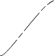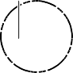

**SAFRAN LANDING SYSTEMS UK Ltd**

CAGE: K0654

PART No. 201587001 AND 201587002 COMPONENT MAINTENANCE MANUAL MAIN LANDING GEAR LEG

38,00mm (1.496in) TO FULL RADIUS

Z

Y

30,00mm (1.181in) THREAD LENGTH

7,00mm (0.276in)

6,3

(250)

110 to 118 DEGREES

27,000 to 27,210mm

(1.0630 to 1.0713in)

6,3

(250)

25,325 to 25,56mm (0.9970 to 1.006in) DRILLED HOLE DIAMETER

26,949mm (1.0610in)

MAJOR DIAMETER OF TAPPED HOLE

THREAD DETAILS:

DETAIL Z

25,974 to 26,067mm

(1.0226 to 1.0263in)

EFFECTIVE DIAMETER OF TAPPED HOLE

10,367mm (0.408in)

MIN. WALL THICKNESS

1,5 PITCH THREAD

25,20mm (0.992in) DIA. MAX.

2,00 to 3,00mm (0.079 to 0.118in)

RADIU

38,00mm (1.496in) REF

25,10mm to 25,20mm (0.988 to 0.992in) DIA. A

1,00 to 2,00mm

(0.039 to 0.079in) RADIUS

REMOVE SHARP CORNERS

DETAIL Y

A321-S-32-12-22-079-0

Repair to Cylinder - Machining

Figure 601

Repair No. 18-2

Page 603 Dec 6/2019

32-12-22

S





**SAFRAN LANDING SYSTEMS UK Ltd**

CAGE: K0654

PART No. 201587001 AND 201587002 COMPONENT MAINTENANCE MANUAL MAIN LANDING GEAR LEG

7,00mm (0.276in)

TO THREAD INSERT

RESTORED

M25 x 1,5 PITCH THREAD

OVERSIZE THREAD INSERT 450258321

21,50 to 22,00mm

(0.846 to 0.866in)

M25 x 1,5 PITCH THREAD

A321A6386-1

Oversize Thread Insert - Installation Figure 602

Repair No. 18-2

Page 604 Dec 6/2019

32-12-22



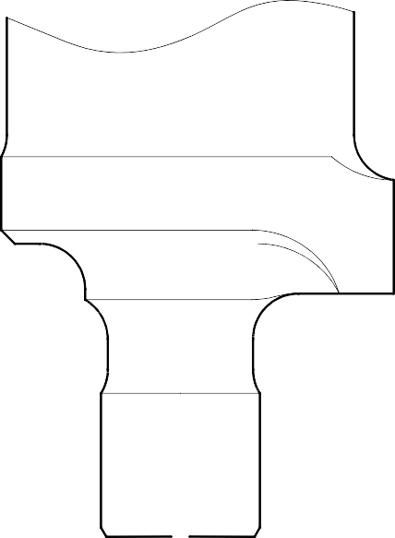

**SAFRAN LANDING SYSTEMS UK Ltd**

CAGE: K0654

PART No. 201587001 AND 201587002 COMPONENT MAINTENANCE MANUAL MAIN LANDING GEAR LEG

Z

10,00mm (0.394in) RADIUS REF.

X

CHROMIUM PLATE TERMINATION

AROUND SLOT TO M-DLPS1031-7

1,75 to 2,25mm

(0.069 to 0.089in)

30 DEGREES

DIA A

DETAIL Y

DETAIL X

1,00 to 3,00mm

(0.039 to 0.118in) CHROMIUM PLATE MUST TERMINATE IN THIS LENGTH

34,326mm (1.3514in) MINIMUM DIAMETER BEFORE CHROMIUM PLATE

34,936 to 34,975mm (1.3754 to 1.3769in) DIAMETER AFTER GRINDING OF

CHROMIUM PLATE

CHROMIUM PLATE TERMINATION TO M-DLPS1031-5

CHROMIUM PLATE DEPOSIT

Y

A321A6750-1

Repair to Cylinder

Figure 601

Repair No. 18-4

Page 602 Dec 6/2019

32-12-22

0,04mm (0.0016in) DIA

Z





**SAFRAN LANDING SYSTEMS UK Ltd**

CAGE: K0654

PART No. 201587001 AND 201587002 COMPONENT MAINTENANCE MANUAL MAIN LANDING GEAR LEG

721,00mm (28.386in) REF.

X

X

0,04mm (0.0016in) DIA

DIA A

Z

11,735mm (0.4620in) MAXIMUM

10,720 to 10,747mm

(0.4220 to 0.4231in)

DIAMETER AFTER MACHINING

29 to 31 DEGREES

NICKEL PLATE

2,0mm (0.08in)

Z

1,6mm (0.63in) RAD

0,80mm (0.031in) RAD

15,00mm (0.590in) DEPTH AFTER MACHINING

12,00mm (0.470in) FINE LIMIT DEPTH

0,30 to 0,70mm

(0.012 to 0.028in)

1,00 to 0,40mm

(0.039 to 0.016in) RAD REF.

10,470 to 10,747mm

(0.4122 to 0.4231in)

DIAMETER AFTER MACHINING NICKEL PLATE

SECTION X-X

A321A6880-1

Repair to Cylinder

Figure 601

Repair No. 18-5

Page 603 Dec 6/2019

32-12-22





**SAFRAN LANDING SYSTEMS UK Ltd**

CAGE: K0654

PART No. 201587001 AND 201587002 COMPONENT MAINTENANCE MANUAL MAIN LANDING GEAR LEG

DIA. A

Y

Z

X

1,75 to 2,25mm

(0.069 to 0.088in)

CHROMIUM PLATE TERMINATION AROUND SLOT TO

M-DLPS1031-7

DIA. A

1,6

(63)

30 DEGREES

10,00mm (0.394in)

RADIUS REF.

DETAIL Y

0,040mm (0.0016in) DIA.

Z

1,00 to 3,00mm

(0.039 to 0.118in) CHROMIUM PLATE RUN OUT

CHROMIUM PLATE TERMINATION TO M-DLPS1031-5

BREAK EDGE

DIAMETER BEFORE

CHROMIUM PLATE

DIAMETER AFTER GRINDING

(FINISHED SIZE)

DIAMETER AFTER CHROMIUM PLATE

DETAIL X

A321-S-32-12-22-042-0

Repair to Cylinder Figure 601

Repair No. 18-6

Page 603 Dec 6/2019

32-12-22





**SAFRAN LANDING SYSTEMS UK Ltd**

CAGE: K0654

PART No. 201587001 AND 201587002 COMPONENT MAINTENANCE MANUAL MAIN LANDING GEAR LEG

DIM. A 784,30mm (30.878in) MIN.

Z

1,75 to 2,25mm

(0.069 to 0.088in)

REFER TO

REPAIR SCHEME 18-4

Y

**Y**

29,5 to 30,5 DEGREES

0,50mm (0.020in)

x 45 DEGREES CHAMFER 2 PLACES

DETAIL Z

29 to 31

DEGREES

0,75 to 1,25mm

(0.029 to 0.049in)

SECTION Y-Y

A321-S-32-12-22-056-0

Repair to Cylinder Figure 601

Repair No. 18-7

Page 602 Dec 6/2019

32-12-22



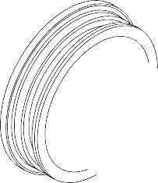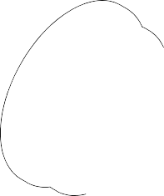

**SAFRAN LANDING SYSTEMS UK Ltd**

CAGE: K0654

PART No. 201587001 AND 201587002 COMPONENT MAINTENANCE MANUAL MAIN LANDING GEAR LEG

**A**

FACE A

A321-T-32-12-22-151-0

Repair to Cylinder Figure 601 - Sheet 1

Repair No. 18-8

Page 603 Mar 18/2025

32-12-22





**SAFRAN LANDING SYSTEMS UK Ltd**

CAGE: K0654

PART No. 201587001 AND 201587002 COMPONENT MAINTENANCE MANUAL MAIN LANDING GEAR LEG

DIM. A

**B**

784,300mm (30.8780in) MIN.

VIEW **A**

1,000 to 1,500mm

(0.0394 to 0.0591in)

x 29,5 to 30,5 DEGREES

CHAMFER

0,250 to 0,750mm

(0.0098 to 0.0295in)

x 44,5 to 45,5 DEGREES CHAMFER

8 PLACES

DI

**Z**

DETAIL **B**

0,750 to 1,250mm

(0.0295 to 0.0492in)

x 29,5 to 30,5 DEGREES CHAMFER

4 PLACES

SECTION **Z-Z**

1,6

(63)

**NOTE:**

THE SURFACE FINISH MUST BE

A321-T-32-12-22-152-0

OR BETTER UNLESS GIVEN DIFFERENTLY.

Repair to Cylinder Figure 601 - Sheet 2

Repair No. 18-8

Page 604 Mar 18/2025

32-12-22

A. C

**Z**





**SAFRAN LANDING SYSTEMS UK Ltd**

CAGE: K0654

PART No. 201587001 AND 201587002 COMPONENT MAINTENANCE MANUAL MAIN LANDING GEAR LEG

DIA. A

FACE C

DIA. B

FACE D

REPAIR POSITIONS

Z

(REFER TO FIGURES 602 AND 603)

9,25mm (0.3642in) MIN. WALL

Z

A321-S-32-12-22-068-0

Repair to Lock Stay Cardan Figure 601

Repair No. 19-1

Page 603 May 31/2019

32-12-22



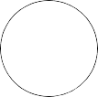

**SAFRAN LANDING SYSTEMS UK Ltd**

CAGE: K0654

PART No. 201587001 AND 201587002 COMPONENT MAINTENANCE MANUAL MAIN LANDING GEAR LEG

F

G

26,810mm (1.0555in) MAX.

26,810mm (1.0555in) MAX.

1,6

(63)

1,6

(63)

FACE D

FACE C

LUG WIDTH EE

LUG WIDTH EE

SPOTFACE

4,75 to 5,25mm (0.187 to 0.207in) RAD.

2 PLACES

1,20mm (0.047in)

x 45 DEGREES CHAMFER

2 PLACES

0,40 to 1,00mm

**X**

**Y**

DIA. B

DIA. A

(0.018 to 0.039in) RAD.

1,6

1,6

(63)

0,20 to 0,40mm

(0.008 to 0.016in) RAD. 2 PLACES

1,00 to 2,00mm (0.039 to 0.079in) RAD.

2 PLACES

1,00 to 2,00mm

(0.039 to 0.079in) RAD.

2 PLACES

70,000mm (2.7559in) REF.

43,80 to 44,20mm

(1.724 to 1.740in) DIA.

43,80 to 44,20mm

(1.724 to 1.740in) DIA.

SECTION **Z-Z** (WITHOUT REPAIR BUSHES) REFER TO FIGURE 601

A321-S-32-12-22-069-0

Repair to Lock Stay Cardan - Machining Figure 602

32-12-22

Repair No. 19-1

Page 604 May 31/2019

0,3mm (0.012in) DIA.

**X**

0,3mm (0.012in) DIA.

**Y**

0,020mm (0.0008in) DIA.

**X**

0,020mm (0.0008in) DIA.

**Y**

0,020mm (0.0008in)

**Y**

(63)

0,020mm (0.0008in)

**X**



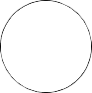

**SAFRAN LANDING SYSTEMS UK Ltd**

CAGE: K0654

PART No. 201587001 AND 201587002 COMPONENT MAINTENANCE MANUAL MAIN LANDING GEAR LEG

23,150 to 23,170mm

23,150 to 23,170mm

(0.9114 to 0.9121in)

5,0mm (0.19in) EXTENT OF WET PRIMER APPLY TO BUSHES ONLY

(0.9114 to 0.9121in)

APPLY SEALANT TO PCS-7200

4 PLACES

0,017mm (0.0007in)

**B**

NO PAINT

NO PAINT

**C**

**D**

**E**

**A**

**B**

2,5

(100)

2,5

(100)

20,000 to 20,021mm (0.7874 to 0.7882in) DIA.

20,000 to 20,021mm (0.7874 to 0.7882in) DIA.

NO PAINT

NO PAINT

REPAIR BUSH 450266106

93,30 to 93,40mm

(3.673 to 3.677in)

ACROSS BUSH TAILS

2 OFF

42,60 to 42,90mm

(1.677 to 1.689in) REF.

**Z-Z**

SECTION

(WITH REPAIR BUSHES) REFER TO FIGURE 601

FACE N

1,6

(63)

**S**

DO NOT PRIMER PAINT

TYPICAL

DIA. M

DO NOT CADMIUM PLATE DO NOT PRIMER PAINT

1,6

(63)

1,00mm (0.039in) x 30 DEGREES CHAMFER

1,00mm (0.039in)

x 60 DEGREES INCLUSIVE CHAMFER

0,60 to 1,00mm

DO NOT CADMIUM PLATE DO NOT PRIMER PAINT

(0.024 to 0.039in) RAD.

A321-S-32-12-22-070-0

REPAIR BUSH (450266106)

Repair Bushes - Machining and Installation Figure 603

32-12-22

Repair No. 19-1

Page 605 May 31/2019

0,020mm (0.0008in) DIA.

**S**

0,020mm (0.0008in)

**S**

0,1mm (0.004in)

**E**

0,020mm (0.0008in) DIA.

**C**

0,020mm (0.0008in) DIA.

**D**

0,017mm (0.0007in)

**A**





**SAFRAN LANDING SYSTEMS UK Ltd**

CAGE: K0654

PART No. 201587001 AND 201587002 COMPONENT MAINTENANCE MANUAL MAIN LANDING GEAR LEG

Y

1,00mm (0.039in)

x 45 DEGREES CHAMFER 2 PLACES

Z

4,75 to 5,25mm

(0.187 to 0.207in) SPOTFACE RADIUS 2 PLACES

DETAIL W

0,40 to 1,00mm (0.016 to 0.039in) RADIUS

2 PLACES

9,75mm (0.384in) MINIMUM WALL THICKNESS

Z

1,00 to 2,00mm

(0.039 to 0.079in) RADIUS 2 PLACES

0,30mm (0.012in) DIA

X

X

DIA A

26,921mm (1.0599in) MAXIMUM

43,80 to 44,20mm (1.724 to 1.740in) DIA 2 PLACES

SECTION Z-Z

(WITHOUT BUSHES)

W

0,020mm (0.0008in)

Y

0,020mm (0.0008in)

X

0,020mm (0.0008in)

X

17,948mm (0.7066in) MINIMUM LUG WIDTH

FACE B

FACE C

A321A6391-1

Repair to Lock Stay Cardan - Machining Figure 601

Repair No. 19-2

Page 603 Dec 6/2019

32-12-22





**SAFRAN LANDING SYSTEMS UK Ltd**

CAGE: K0654

PART No. 201587001 AND 201587002 COMPONENT MAINTENANCE MANUAL MAIN LANDING GEAR LEG

V

APPLY SEALANT TO PCS-7200

2 PLACES

SECTION Z-Z (WITH BUSHES) REFER TO FIGURE 601

REPAIR BUSH

U

0,020mm (0.0008in) DIA

U

20,00 to 20,021mm

(0.7874 to 0.7882in) DIA

24,959 to 24,980mm

(0.9826 to 0.9835in)

0,05mm (0,002in)

V

0,015mm (0.0006in)

FACE E

0,50mm (0.020in)

x 45 DEGREES CHAMFER

DIA

D

REPAIR BUSH 450266107

0,30 to 0,50mm

(0.012 to 0.020in) RADIUS

0,020mm (0.0008in)

A321A6393-1

Repair Bushes - Machining and Installation Figure 602

Repair No. 19-2

Page 604 Dec 6/2019

32-12-22

0,017mm (0.0007in)

U

0,017mm (0.0007in)

U





**SAFRAN LANDING SYSTEMS UK Ltd**

CAGE: K0654

PART No. 201587001 AND 201587002 COMPONENT MAINTENANCE MANUAL MAIN LANDING GEAR LEG

X

0,03mm (0.001in)

Z

X

0,50 to 0,64mm

(0.020 to 0.025in) x 90 DEGREES INCLUSIVE CHAMFER. TYPICAL

DIA. A

SECTION X-X

285,00 to 286,00mm

(11.220 to 11.260in)

Z

12,700mm

0.500in) REF

X

SECTION X-X

(WITH BEARING)

X

A321A6768-1

Repair to Lower Slave Link Figure 601

Repair No. 20-1

Page 603 Dec 6/2019

32-12-22

12,687 to

(0.499 to





**SAFRAN LANDING SYSTEMS UK Ltd**

CAGE: K0654

PART No. 201587001 AND 201587002 COMPONENT MAINTENANCE MANUAL MAIN LANDING GEAR LEG

X

X

NO PAINT ON SPOTFACES

FACE B

9,00 to 11,50mm

(0.354 to 0.453in)

0,75mm (0.029in) RAD.

DIM. C

25,25mm (0.994in)

MAXIMUM

Z

0,80 to 1,20mm (0.031 to 0.047in)

x 45 DEGREES CHAMFER

SECTION X-X

(WITHOUT BUSH)

DIA. A

17,168mm (0.6759in) MAXIMUM.

LIGHT PRIMER ONLY IN BORE

A321-S-32-12-22-013-1

Repair to Transfer Block - Machining Figure 601

Repair No. 21-1

32-12-22 Dec 6/2019

Page 603

3,2

(125)

1,6

(63)

0,05mm (0.002in) DIA.

Z

0,025mm (0.001in)

Z





**SAFRAN LANDING SYSTEMS UK Ltd**

CAGE: K0654

PART No. 201587001 AND 201587002 COMPONENT MAINTENANCE MANUAL MAIN LANDING GEAR LEG

SEALANT TO PCS-7200

SEALANT TO PCS-7200

SECTION X-X

(WITH BUSH)

REPAIR BUSH 450217865

9,525 to 9,547mm (0.3750 to 0.3758in) DIA. REF.

FACE F

DIM. E

0,95 to 1,45mm

(0.037 to 0.057in)

x 15 DEGREES CHAMFER

DO NOT CADMIUM PLATE

DIA. D

1,6

(63)

0,50 to 0,80mm

(0.020 to 0.031in) RAD.

0,025mm (0.001in) DIA

REPAIR BUSH

A321-S-32-12-22-020-0

Repair

Bush - Machining and Installation Figure 602

Repair No. 21-1

32-12-22 Dec 6/2019

Page 604

1,6

(63)





**SAFRAN LANDING SYSTEMS UK Ltd**

CAGE: K0654

PART No. 201587001 AND 201587002 COMPONENT MAINTENANCE MANUAL MAIN LANDING GEAR LEG

**X**

**X**

DIA. A

17.918mm (0.7054in) MAXIMUM

**Y**

0,80 to 1,20mm

(0.031 to 0.047in)

x 45 DEGREES CHAMFER

0,05mm (0.002in) DIA

**Y**

SECTION **X-X**

(WITHOUT BUSH)

A321A6774-2

Repair to Transfer Block - Machining Figure 601

Repair No. 21-2

32-12-22 Mar 20/2020

Page 603





**SAFRAN LANDING SYSTEMS UK Ltd**

CAGE: K0654

PART No. 201587001 AND 201587002 COMPONENT MAINTENANCE MANUAL MAIN LANDING GEAR LEG

SEALANT TO PCS-7200

SECTION X-X

(WITH BUSH)

REPAIR BUSH 450217864

12,700 to 12,727mm (0.5000 to 0.5010in) DIA REF.

1,50 to 1,75mm (0.059 to 0.068in)

0,95 to 1,45mm

(0.037 to 0.057in)

x 15 DEGREES CHAMFER

DIA. B

0,50 to 0,80mm

(0.020 to 0.031in) RAD.

0,025mm (0.001in) DIA

REPAIR BUSH

A321A6775-1

Repair Bush - Machining and Installation Figure 602

Repair No. 21-2

32-12-22 Dec 6/2019

Page 604





**SAFRAN LANDING SYSTEMS UK Ltd**

CAGE: K0654

PART No. 201587001 AND 201587002 COMPONENT MAINTENANCE MANUAL MAIN LANDING GEAR LEG

**X**

**X**

NO PAINT

DIA. A

**Y**

16,527mm (0.6507in) MAXIMUM

NO PAINT

**Z**

SECTION **X-X**

(WITHOUT THREADED INSERT)

1,6

(63)

0,80 to 1,20mm

(0.031 to 0.047in) x 45 DEGREES CHAMFER

0,05mm (0.002in) DIA

**Z**

16,40mm (0.646in)

DIA. A

MAXIMUM

0,750mm

DIA. A

(0.0295in) RAD.

DETAIL **Y**

A321-S-32-12-22-031-0

Repair to Transfer Block - Machining Figure 601

Repair No. 21-3

32-12-22 Sep 16/2016

Page 603





**SAFRAN LANDING SYSTEMS UK Ltd**

CAGE: K0654

PART No. 201587001 AND 201587002 COMPONENT MAINTENANCE MANUAL MAIN LANDING GEAR LEG

SECTION **X-X**

(WITH THREADED INSERT)

REPAIR THREADED INSERT

14,00mm (0.551in)

APPLY PAINT

DIA. C

0,50 to 0,80mm (0.020 to 0.032in) RAD.

0,75 to 1,25mm

(0.030 to 0.050in)

x 60 DEGREES INCLUSIVE CHAMFER

REPAIR THREADED INSERT

A321-S-32-12-22-032-0

Repair to Threaded Insert - Machining and Installation Figure 602

Repair No. 21-3

32-12-22 Sep 16/2016

Page 604





**SAFRAN LANDING SYSTEMS UK Ltd**

CAGE: K0654

PART No. 201587001 AND 201587002 COMPONENT MAINTENANCE MANUAL MAIN LANDING GEAR LEG

X

X

NO PAINT ON SPOTFACES

FACE B

9,00 to 11,50mm

(0.354 to 0.453in)

DIM. C

25,25mm (0.994in)

MAXIMUM

0,80 to 1,20mm

(0.031 to 0.047in)

x 45 DEGREES CHAMFER

0,75mm (0.030in) RAD.

3,2

(125)

Z

1,6

(63)

DIA. A

17,168mm (0.6759in)

MAXIMUM. LIGHT COAT OF PRIMER ONLY

SECTION X-X

(WITHOUT BUSH)

A321-S-32-12-22-002-1

Repair to Transfer Block - Machining Figure 601

32-12-22

Repair No. 21-4

Page 603

Dec 6/2019

0,05mm (0.002in) DIA.

Z

0,025mm (0.001in)

Z





**SAFRAN LANDING SYSTEMS UK Ltd**

CAGE: K0654

PART No. 201587001 AND 201587002 COMPONENT MAINTENANCE MANUAL MAIN LANDING GEAR LEG

APPLY SEALANT TO PCS-7200

REPAIR BUSH 450217865

9,525 to 9,547mm (0.3750 to 0.3758in) DIA.

SECTION X-X

(WITH BUSH)

1,6

(63)

FACE F

DIM. E

0,95 to 1,45mm

(0.037 to 0.057in)

x 30 DEGREES INCLUSIVE CHAMFER

DO NOT CADMIUM

PLATE

DIA. D

1,6

(63)

0,50 to 0,80mm

(0.020 to 0.031in) RAD.

0,025mm (0.001in) DIA.

REPAIR BUSH 450217865

A321-S-32-12-22-003-0

Repair Bush - Machining and Installation Figure 602

Repair No. 21-4

Page 604

Dec 6/2019

32-12-22





**SAFRAN LANDING SYSTEMS UK Ltd**

CAGE: K0654

PART No. 201587001 AND 201587002 COMPONENT MAINTENANCE MANUAL MAIN LANDING GEAR LEG

Z

Z

NO PAINT ON SPOTFACES

3,2

(125)

1,6

(63)

DIA. A

0,80 to 1,20mm (0.031 to 0.047in)

x 45 DEGREES CHAMFER

APPLY LIGHT COAT OF PRIMER ONLY

SECTION Z-Z

(WITHOUT BUSH)

A321-S-32-12-22-034-0

Repair to Transfer Block - Machining Figure 601

Repair No. 21-5

32-12-22 Dec 6/2019

Page 603

0,05mm (0.002in) DIA.

Y

Y





**SAFRAN LANDING SYSTEMS UK Ltd**

CAGE: K0654

PART No. 201587001 AND 201587002 COMPONENT MAINTENANCE MANUAL MAIN LANDING GEAR LEG

1,6

(63)

FACE W

1,50 to 1,75mm

(0.059 to 0.068in)

0,95 to 1,45mm (0.037 to 0.057in)

x 30 DEGREES INCLUSIVE CHAMFER

DO NOT CADMIUM

PLATE

1,6

(63)

X

0,50 to 0,80mm

(0.020 to 0.031in) RAD.

REPAIR BUSH 450217864

REPAIR BUSH 450217864

12,700 to 12,727mm (0.5000 to 0.5010in) DIA. CHECK DIA.

SEALANT TO

PCS-7200

SECTION Z-Z

(WITH BUSH)

A321-S-32-12-22-035-0

Repair Bush - Machining and Installation Figure 602

Repair No. 21-5

32-12-22 Dec 6/2019

Page 604

DIA. B

0,025mm (0.001in) DIA.

X





**SAFRAN LANDING SYSTEMS UK Ltd**

CAGE: K0654

PART No. 201587001 AND 201587002 COMPONENT MAINTENANCE MANUAL MAIN LANDING GEAR LEG

X

X

NO PAINT

0,80 to 1,20mm (0.031 to 0.047in) x 45 DEGREES CHAMFER

DIM. A

NO PAINT

Y

Z

1,6

(63)

SECTION X-X

(WITHOUT THREADED INSERT)

0,05mm (0.002in) DIA.

Z

16,40mm (0.646in)

DIA. A

MAXIMUM

0,750mm (0.0295in) RAD.

DETAIL Y

DIA. A

A321-S-32-12-22-049-0

Repair to Transfer Block - Machining Figure 601

Repair No. 21-6

32-12-22 Dec 6/2019

Page 603





**SAFRAN LANDING SYSTEMS UK Ltd**

CAGE: K0654

PART No. 201587001 AND 201587002 COMPONENT MAINTENANCE MANUAL MAIN LANDING GEAR LEG

SECTION X-X

(WITH THREADED INSERT)

REPAIR THREADED INSERT

14,00mm (0.551in)

APPLY PAINT

DIA. C

0,50 to 0,80mm

(0.020 to 0.032in) RAD.

0,75 to 1,25mm

(0.030 to 0.050in)

x 60 DEGREES INCLUSIVE CHAMFER

REPAIR THREADED INSERT

A321-S-32-12-22-050-0

Repair Threaded Insert - Machining and Installation Figure 602

Repair No. 21-6

32-12-22 Dec 6/2019

Page 604





**SAFRAN LANDING SYSTEMS UK Ltd**

CAGE: K0654

PART No. 201587001 AND 201587002 COMPONENT MAINTENANCE MANUAL MAIN LANDING GEAR LEG

Z

Z

APPLY SEALANT TO PCS-7200 (8 HOLES)

SECTION Z-Z

A321A7132-1

Repair to Spherical Bearing Figure 601

Repair No. 22-1

32-12-22 Dec 6/2019

Page 602





**SAFRAN LANDING SYSTEMS UK Ltd**

CAGE: K0654

PART No. 201587001 AND 201587002 COMPONENT MAINTENANCE MANUAL MAIN LANDING GEAR LEG

X

Z

Y

19.5 to 20.5

SMOOTH BLEND

DEGREES

DIA. A

DIA. B

311,75 to 312,25mm

(12.273 to 12.293in) REF.

THIS LUG (2 PLACES) MUST NOT

BE CHROMIUM PLATED

CHROMIUM PLATE TERMINATION

CHROMIUM PLATE TERMINATION TO M-DLPS1031-6

94,378mm (3.7156in)

MIN. DIA. BEFORE

104,378mm (4.1093in) DIA. MIN. BEFORE CHROMIUM PLATE

CHROMIUM PLATE

94,966 to 94,988mm

104,966 to 104,988mm (4.1325 to 4.1334in) DIA. AFTER GRINDING THE CHROMIUM PLATE

(3.7388 to 3.7397in) DIA. AFTER GRINDING

THE CHROMIUM PLATE

CHROMIUM PLATE DEPOSIT

DETAIL X

CHROMIUM PLATE DEPOSIT

DETAIL Y

111,75 to 112,25mm (4.399 to 4.419in) EXTENT OF FINE LIMIT

TO END FACE

OF PIN

BLENDED EDGES

18,00 to 20,00mm (0.708 to 0.787in) RAD. BEFORE CHROMIUM PLATE 12,00 to 15,00mm (0.472 to 0.590in)

RAD. AFTER CHROMIUM PLATE

5,000 to 6,000mm (0.1968 to 0.2362in) RAD.

DETAIL Z

104,966 to 104,988mm (4.1325 to 4.1334in) DIA. AFTER GRINDING

THE CHROMIUM PLATE

CHROMIUM PLATE DEPOSIT

CHROMIUM PLATE DEPOSIT

94,966 to 94,988mm

94,378mm (3.7156in) DIA. MIN. BEFORE CHROMIUM PLATE

(3.7388 to 3.7397in) DIA. AFTER GRINDING

THE CHROMIUM PLATE

104,378mm (4.1093in) MIN. DIA. BEFORE CHROMIUM PLATE

A321-S-32-12-22-021-0

Repair to Pintle Pin Figure 601

Repair No. 23-1

Page 603 Dec 9/2016

32-12-22

TO M-DLPS1031-6





**SAFRAN LANDING SYSTEMS UK Ltd**

CAGE: K0654

PART No. 201587001 AND 201587002 COMPONENT MAINTENANCE MANUAL MAIN LANDING GEAR LEG

4,700mm (0.185in) MINIMUM

VIEW ON ARROW Y

6,80mm (0.268in) MINIMUM

BOTH SIDES

Y

DIA. A

18,00 to 18,10mm

(0.708 to 0.713in)

90 DEGREES

0,90 to 1,00mm

(0.035 to 0.039in) DEPTH OF CHAMFER

X

DETAIL

11,00mm (0.433in) REF.

X

DIA. B

17,00 to 17,10mm

(0.669 to 0.673in)

A321A7161-1

Repair to Pintle Pin Figure 601

Repair No. 23-2

32-12-22 Dec 6/2019

Page 603





**SAFRAN LANDING SYSTEMS UK Ltd**

CAGE: K0654

PART No. 201587001 AND 201587002 COMPONENT MAINTENANCE MANUAL MAIN LANDING GEAR LEG

13,00mm (0.512in)

2,00mm (0.079in)

2,00mm (0.079in)

0,40mm (0.016in) RAD MAXIMUM

20,00mm (0.787in) DIA.

14,00mm (0.551in) DIA.

DIAMETER

C

15

DEGREES

45

DEGREES

DIAMETER BEFORE CADMIUM PLATE 16,535 to 16,558mm (0.6510 to 0.6519in)

DIAMETER AFTER CADMIUM PLATE 16,495 to 16,538mm (0.6494 to 0.6511in)

Z

W

X

MACHINE BOTH ENDS OF BUSH TO INNER AND OUTER PROFILE OF PIN

X

SECTION X-X

INSTALLATION AND MACHINING

DIAMETER BEFORE CADMIUM PLATE 15,535 to 15,558mm (0.6116 to 0.6125in) DIAMETER AFTER CADMIUM PLATE 15,495 to 15,538mm (0.6100 to 0.6117in)

A321A7162-1

Repair Bushes - Machining and Installation Figure 602

Repair No. 23-2

32-12-22 Dec 6/2019

Page 604

0,025mm (0.0001in)

W

0,05mm (0.002in) DIA

Z

0,05mm (0.002in)

Z





**SAFRAN LANDING SYSTEMS UK Ltd**

CAGE: K0654

PART No. 201587001 AND 201587002 COMPONENT MAINTENANCE MANUAL MAIN LANDING GEAR LEG

Z

33,75 to 34,25mm (1.329 to 1.348in) REF.

Z

Y

3,2

(125)

DIA. A

16,10 to 17,60mm (0.634 to 0.693in)

SECTION Z-Z

(WITHOUT BUSHES)

A321-S-32-12-22-015-0

Repair to Harness Support Bracket Figure 601

Repair No. 24-1

Page 603

Dec 6/2019

32-12-22

0,10mm (0.004in)

Y

0,05mm (0.002in)

Y





**SAFRAN LANDING SYSTEMS UK Ltd**

CAGE: K0654

PART No. 201587001 AND 201587002 COMPONENT MAINTENANCE MANUAL MAIN LANDING GEAR LEG

80,00mm (3.150in) REF.

39,75 to 40,25mm (1.565 to 1.585in) REF.

NO PAINT OR PRIMER

X

60,076 to 60,122mm (2.3652 to 2.3670in) DIA. REF. LIGHT COAT OF PRIMER ONLY

LIGHT COAT OF PRIMER ONLY

REPAIR BUSH 450237531

2 OFF

3,2

(125)

13,000 to 13,100 mm

(0.5118 to 0.5157 in) DIA.

25,00mm (0.984in) DIA. SPOTFACE REF.

SECTION Z-Z

(WITH BUSHES)

14,75 to 15,25mm

(0.581 to 0.600in)

3,2

(125)

10,75 to 11,25mm (0.424 to 0.442in) DIA.

DIA. B

1,25 to 1,75mm (0.049 to 0.069in)

x 29 to 31 DEGREES

INCLUSIVE CHAMFER

REPAIR BUSH 450237531

A321-S-32-12-22-016-0

Repair Bushes - Machining and Installation Figure 602

32-12-22

Repair No. 24-1

Page 604

Dec 6/2019

3,2

(125)

3,2

(125)

0,10mm (0.004in) DIA.

X

0,05mm (0.002in) DIA.

X





**SAFRAN LANDING SYSTEMS UK Ltd**

CAGE: K0654

PART No. 201587001 AND 201587002 COMPONENT MAINTENANCE MANUAL MAIN LANDING GEAR LEG

8,40 to 8,50mm (0.331 to 0.335in) REF.

X

0,60 to 0,80mm

(0.024 to 0.031in) RADIUS

REF.

BEFORE CHROMIUM

0,8

40 to 50 DEGREES

(32) PLATE

REF.

0,4 AFTER CHROMIUM

(16) PLATE

DIA. A

15 DEGREES REF.

1,00 to 2,00mm

(0.040 to 0.079in)

Y

0,075mm (0.0030in) DIA.

REF.

Y

Z

0,010mm (0.0004in)

Z

EXTENT OF SHOT PEEN

CHROMIUM PLATE TERMINATION

TO M-DLPS1031-2

CHROMIUM PLATE TERMINATION

TO M-DLPS1031-6

28,65mm (1.128in) LENGTH OF CHROMIUM PLATE

DIAMETER A

BEFORE CHROMIUM PLATE

DIAMETER A

AFTER GRINDING THE CHROMIUM PLATE

DIAMETER A

AFTER CHROMIUM PLATE

DETAIL X

A321-S-32-12-22-051-0

Repair to Retaining Pin Figure 601

32-12-22

Repair No. 25-1

Page 603 Dec 6/2019





**SAFRAN LANDING SYSTEMS UK Ltd**

CAGE: K0654

PART No. 201587001 AND 201587002 COMPONENT MAINTENANCE MANUAL MAIN LANDING GEAR LEG

8,40 to 8,60mm (0.331 to 0.338in) REF.

X

0,60 to 0,80mm

(0.024 to 0.031in) RADIUS

REF.

BEFORE CHROMIUM

0,8

40 to 50 DEGREES

(32) PLATE

REF.

AFTER CHROMIUM

0,4

(16) PLATE

DIA. A

15 DEGREES REF.

1,00 to 2,00mm

(0.040 to 0.079in)

Y

0,075mm (0.0030in) DIA.

REF.

Y

Z

0,010mm (0.0004in)

Z

EXTENT OF SHOT PEEN

CHROMIUM PLATE TERMINATION

TO M-DLPS1031-2

CHROMIUM PLATE TERMINATION

TO M-DLPS1031-6

30,00mm (1.181in) LENGTH OF CHROMIUM PLATE

DIAMETER A

BEFORE CHROMIUM PLATE

DIAMETER A

AFTER GRINDING THE CHROMIUM PLATE

DIAMETER A

AFTER CHROMIUM PLATE

DETAIL X

A320-S-32-12-22-082-0

Repair to Retaining Pin Figure 601

Repair No. 25-2

Page 603 Dec 6/2019

32-12-22



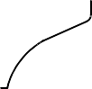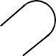

**SAFRAN LANDING SYSTEMS UK Ltd**

CAGE: K0654

PART No. 201587001 AND 201587002 COMPONENT MAINTENANCE MANUAL MAIN LANDING GEAR LEG

68,00mm (2.677in) REF.

NO PAINT ON THIS FACE

Z

36,50mm (1.437in)

REF.

14,60 to 14,70mm (0.5748 to 0.5787in) DIA.

REF.

Y

X

1,6

(63)

DIA. A

LIGHT COAT OF PRIMER ONLY

3,2

(125)

59,20mm (2.331in) REF.

29,60mm (1.165in) REF.

3,2

(125)

NO PAINT

DIA. A

NO PAINT

1,6

(63)

NO PAINT

VIEW Z (WITHOUT SLEEVE)

A321-S-32-12-22-058-0

Repair to Upper Pivot Bracket - Machining Figure 601

32-12-22

Repair No. 26-1

Page 603 Dec 6/2019

0,1mm (0.004in) DIA.

X

0,05 mm (0.002in) DIA.

X



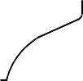

**SAFRAN LANDING SYSTEMS UK Ltd**

CAGE: K0654

PART No. 201587001 AND 201587002 COMPONENT MAINTENANCE MANUAL MAIN LANDING GEAR LEG

71,00mm (2.795in)

1,50mm (0.059in)

30 DEGREES

58,00mm (2.323in) DIA.

DIA. B

REPAIR SLEEVE 450265251

68,00mm (2.677in) REF.

V

36,50mm (1.437in)

REF.

W

14,60 to 14,70mm (0.5748 to 0.5787in) DIA.

REF.

REPAIR SLEEVE 450265251

60,076 to 60,122mm (2.3652 to 2.3670in) DIA.

PRODUCE CROSS

HOLES IN REPAIR SLEEVE

A321-S-32-12-22-059-0

Repair Sleeve - Machining and Installation Figure 602

32-12-22

Repair No. 26-1

Page 604

Dec 6/2019

0,1mm (0.004in) DIA.

V

0,05 mm (0.002in) DIA.

V

0,1mm (0.004in) DIA.

W

0,05mm (0.002in) DIA.

W

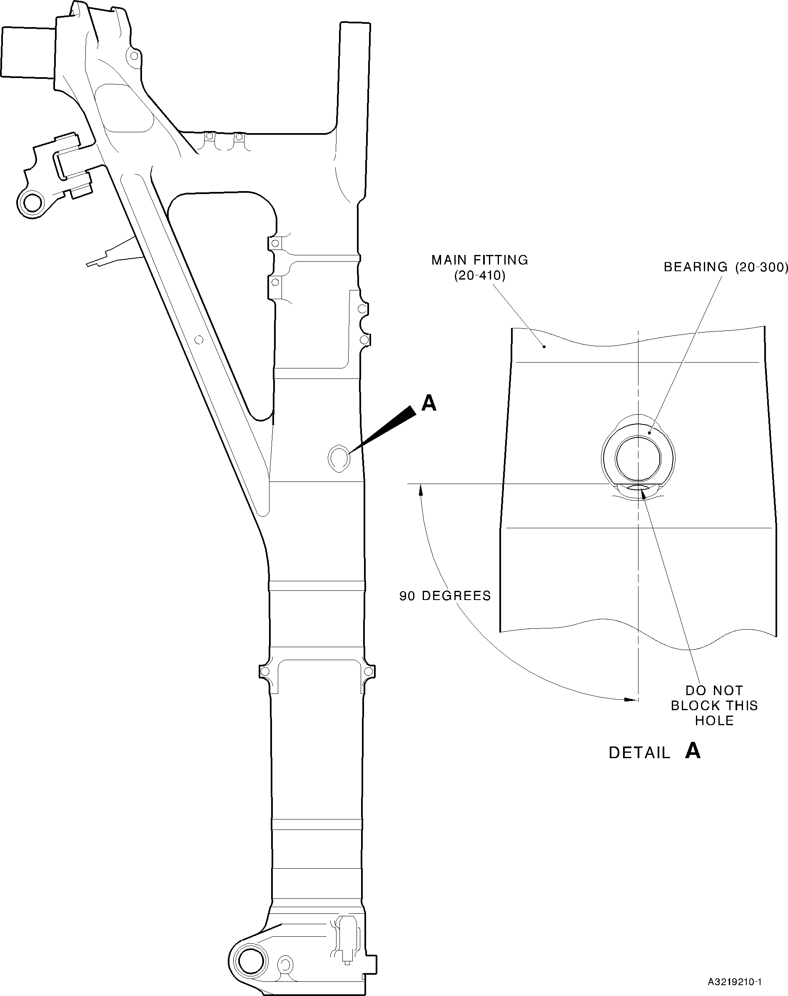

**SAFRAN LANDING SYSTEMS UK Ltd**

CAGE: K0654

PART No. 201587001 AND 201587002 COMPONENT MAINTENANCE MANUAL MAIN LANDING GEAR LEG

Main Fitting Subassembly (20-90) - Bearing (20-300) - Installation Figure 701 (Sheet 1 of 2)

32-12-22

Page 711 Mar 20/2020





**SAFRAN LANDING SYSTEMS UK Ltd**

CAGE: K0654

PART No. 201587001 AND 201587002 COMPONENT MAINTENANCE MANUAL MAIN LANDING GEAR LEG

SPRAY ARDROX AV100D TO THE BORE

OF THE MAIN FITTING SUBASSEMBLY (20-90) AND (20-90A)

NO ARDROX BEYOND THIS POINT

48,000 to 53,000mm

(1.8897 to 2.0866in)

MAIN FITTING

SUBASSEMBLY (20-90) AND (20-90A)

A321-S-32-12-22-083-1

Main Fitting Subassembly (20-90) - Ardrox Application Figure 701 (Sheet 2 of 2)

32-12-22

Page 712 Mar 20/2020





**SAFRAN LANDING SYSTEMS UK Ltd**

CAGE: K0654

PART No. 201587001 AND 201587002 COMPONENT MAINTENANCE MANUAL MAIN LANDING GEAR LEG

WIRING DIAGRAM PLATE

(1-110)

**F**

LABEL (20-30)

**E**

70,00 to 80,00mm

(2.76 to 3.14in)

DETAIL **F**

**A**

=

=

20,00mm (0.787in)

12,5mm (0.50in)

DETAIL **A**

LABEL TO BE IN LINE WITH LUG

LABEL (20-10)

**B**

DETAIL **E**

**D**D

LABEL (20-80)

40,00mm (1.575in)

DETAIL **B**

LABEL (20-60)

**C**

LABEL (20-40)

20,00mm (0.787in)

6,00mm (0.236in)

16,4mm (0.65in)

DETAIL **D**

DETAIL **C**

A3219211-1

Labels (20-10, 20-30, 20-40, 20-60 and 20-80) and wiring diagram plate (1-110) - Installation

Figure 702

32-12-22

Page 713 Mar 20/2020



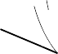

**SAFRAN LANDING SYSTEMS UK Ltd**

CAGE: K0654

PART No. 201587001 AND 201587002 COMPONENT MAINTENANCE MANUAL MAIN LANDING GEAR LEG

**T**

**U** (REFER TO SHEET 5)

**T** (REFER TO SHEET 6)

**U**

(REFER TO

SHEET 5)

**V**

**V**

**Z**

ORIENTATE BUSHES AS SHOWN

DRAG ARM UPPER BUSHES (20-390A)

**Z**

**A**

VIEW **A**

DRAG ARM SLEEVE (20-370A)

APPLY FILLET OF SEALANT

(TYPICAL 2 PLACES)

0,50 to 0,75mm

(0.019 to 0.029in)

**W**

**W**

(REFER TO SHEET 4)

SECTION **S-S**

MAIN FITTING (20-410B OR 410C OR 410D)

**Y**

APPLY FILLET OF SEALANT

(TYPICAL 2 PLACES)

(REFER TO SHEET 2)

BUSH (20-400)

(TYPICAL 2 PLACES)

20,000 to 20,021mm

(0.7873 to 0.7882in) CHECK DIAMETER

43,233 to 43,270mm

(1.7020 to 1.7035in)

**Y**

SECTION **Z-Z**

**X**

(REFER TO SHEET 3)

**X**

A321-T-321222-0013-01

Main Fitting Subassembly (20-90B) or (20-90C) - Installation Figure 703 (Sheet 1 of 6)

32-12-22

Page 722 Sep 17/2021

**S**

**S**

1,6

(63)

1,6

(63)

1,6

(63)



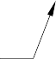

**SAFRAN LANDING SYSTEMS UK Ltd**

CAGE: K0654

PART No. 201587001 AND 201587002 COMPONENT MAINTENANCE MANUAL MAIN LANDING GEAR LEG

APPLY PRIMER PAINT TO BUSH DIA. AND FLANGE UNDERSIDE ONLY TO THIS AREA

BUSH (20-350)

APPLY PRIMER PAINT TO BUSH DIA AND FLANGE UNDERSIDE ONLY TO THIS AREA

27,000 to 29,000mm

(1.0629 to 1.1417in)

BUSH (20-340)

APPLY JOINTING COMPOUND TO THE BORE ONLY TO THIS AREA 5,000 to 7,000mm (0.1968 to 0.2755in)

14,000 to 16,000mm

(0.5511 to 0.6299in)

APPLY JOINTING COMPOUND TO THE BORE ONLY TO THIS AREA 5,000 to 7,000mm (0.1968 to 0.2755in)

SECTION **Y-Y**

(WITHOUT BUSHES)

APPLY FILLET OF SEALANT

1,6

(63)

70,000 to 70,030mm

(2.7558 to 2.7570in) CHECK DIAMETER

BUSH (20-350)

BUSH (20-340)

137,917 to 137,957mm

(5.4297 to 5.4313in)

APPLY FILLET OF SEALANT

1,6

(63)

SECTION **Y-Y**

A321-T-321222-0014-00

Main Fitting Subassembly (20-90B) or (20-90C) - Installation Figure 703 (Sheet 2 of 6)

32-12-22

Page 723 Sep 17/2021



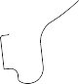

**SAFRAN LANDING SYSTEMS UK Ltd**

CAGE: K0654

PART No. 201587001 AND 201587002 COMPONENT MAINTENANCE MANUAL MAIN LANDING GEAR LEG

5,000 to 7,000mm (0.1968 to 0.2755in) APPLY JOINTING COMPOUND TO THE BORE ONLY TO THIS AREA

(TYPICAL 2 PLACES)

22,000 to 24,000mm

(0.8661 to 0.9448in)

(TYPICAL 2 PLACES)

APPLY PRIMER PAINT TO BUSH DIA AND FLANGE UNDERSIDE ONLY

TO THIS AREA (TYPICAL 2 BUSHES)

26,000 to 26,021mm

(1.0236 to 1.0244in) CHECK DIAMETER (TYPICAL 3 PLACES)

APPLY FILLET

OF SEALANT

APPLY FILLET

OF SEALANT

DETAIL **C**

BUSH (20-320)

(TYPICAL 3 PLACES)

DETAIL **B**

(WITHOUT BUSHES)

APPLY FILLET OF SEALANT (TYPICAL 2 PLACES)

1,6

(63)

1,20mm (0.047in) x 60 DEGREES INCLUSIVE CHAMFER (TYPICAL 2 BUSHES)

150,917 to 150,957mm

(5.9415 to 5.9431in)

BUSH (20-330)

(TYPICAL 2 PLACES)

60,000 to 60,030mm

(2.3621 to 2.3633in) CHECK DIAMETER

**B**

**C**

SECTION **X-X**

Main Fitting Subassembly (20-90B) or (20-90C) - Installation Figure 703 (Sheet 3 of 6)

A321-T-321222-0015-00

32-12-22

Page 724 Sep 17/2021

1,6

(63)

1,6

(63)

0,8

(32)



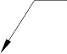

**SAFRAN LANDING SYSTEMS UK Ltd**

CAGE: K0654

PART No. 201587001 AND 201587002 COMPONENT MAINTENANCE MANUAL MAIN LANDING GEAR LEG

BEARING (20-310)

SPRAY ARDROX AV100D TO THE BORE

OF THE MAIN FITTING (20-410B OR 410C OR 410D)

46,825 to 46,864mm

(1.8435 to 1.8450in)

CHECK DIAMETER

60 DEGREES

BEARING (20-300)

1,20mm (0.047in)

36,000 to 36,025mm

(1.4173 to 1.4183in) CHECK DIAMETER

**D**

APPLY FILLET OF SEALANT

(TYPICAL 2 PLACES)

222,500 to 222,750mm

(8.7598 to 8.7696in)

SECTION **W-W**

SPRAY ARDROX AV100D TO THE BORE

OF THE MAIN FITTING (20-410B OR 410C OR 410D)

90 DEGREES

DO NOT BLOCK THIS HOLE WITH SEALANT

NO ARDROX BEYOND THIS POINT

BEARING (20-300)

48,000 to 53,000mm

(1.8897 to 2.0866in)

VIEW **D**

MAIN FITTING (20-410B OR 410C OR 410D)

A321-T-321222-0016-01

Main Fitting Subassembly (20-90B) or (20-90C) - Installation Figure 703 (Sheet 4 of 6)

32-12-22

Page 725 Sep 17/2021

1,6

(63)

1,6

(63)

(63)

1,6

(63)

1,6

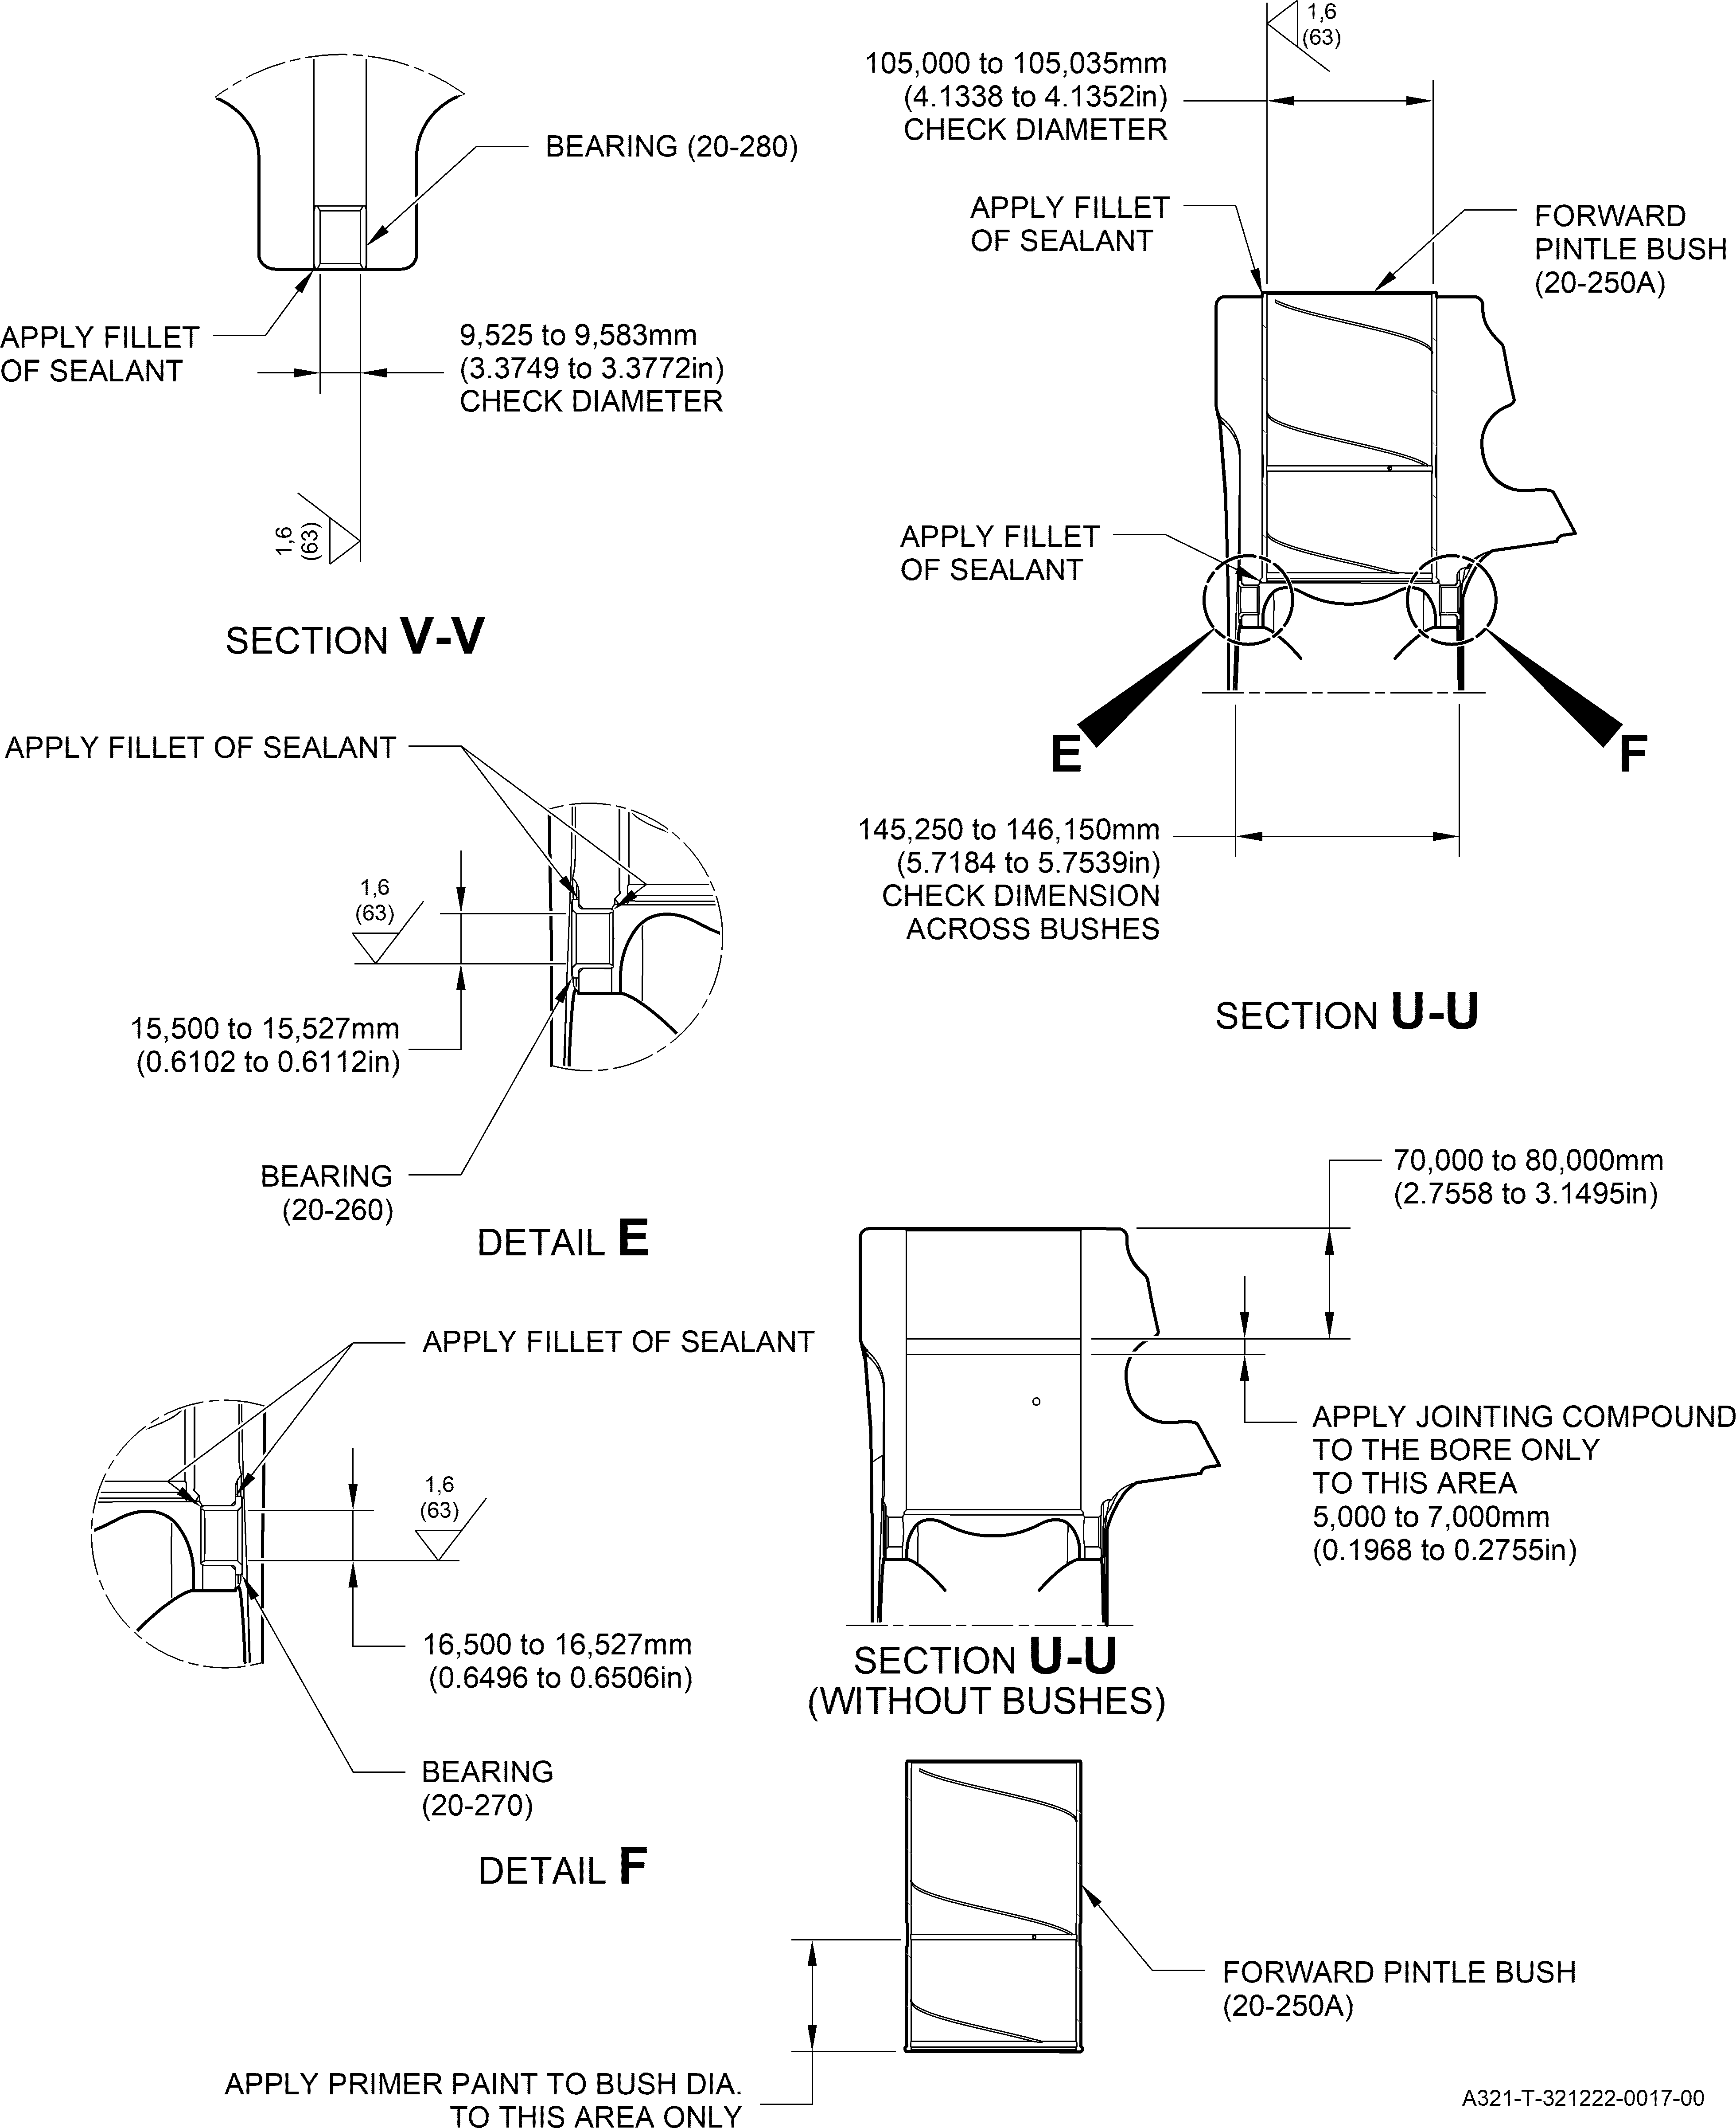

**SAFRAN LANDING SYSTEMS UK Ltd**

CAGE: K0654

PART No. 201587001 AND 201587002 COMPONENT MAINTENANCE MANUAL MAIN LANDING GEAR LEG

Main Fitting Subassembly (20-90B) or (20-90C) - Installation Figure 703 (Sheet 5 of 6)

32-12-22

Page 726 Sep 17/2021

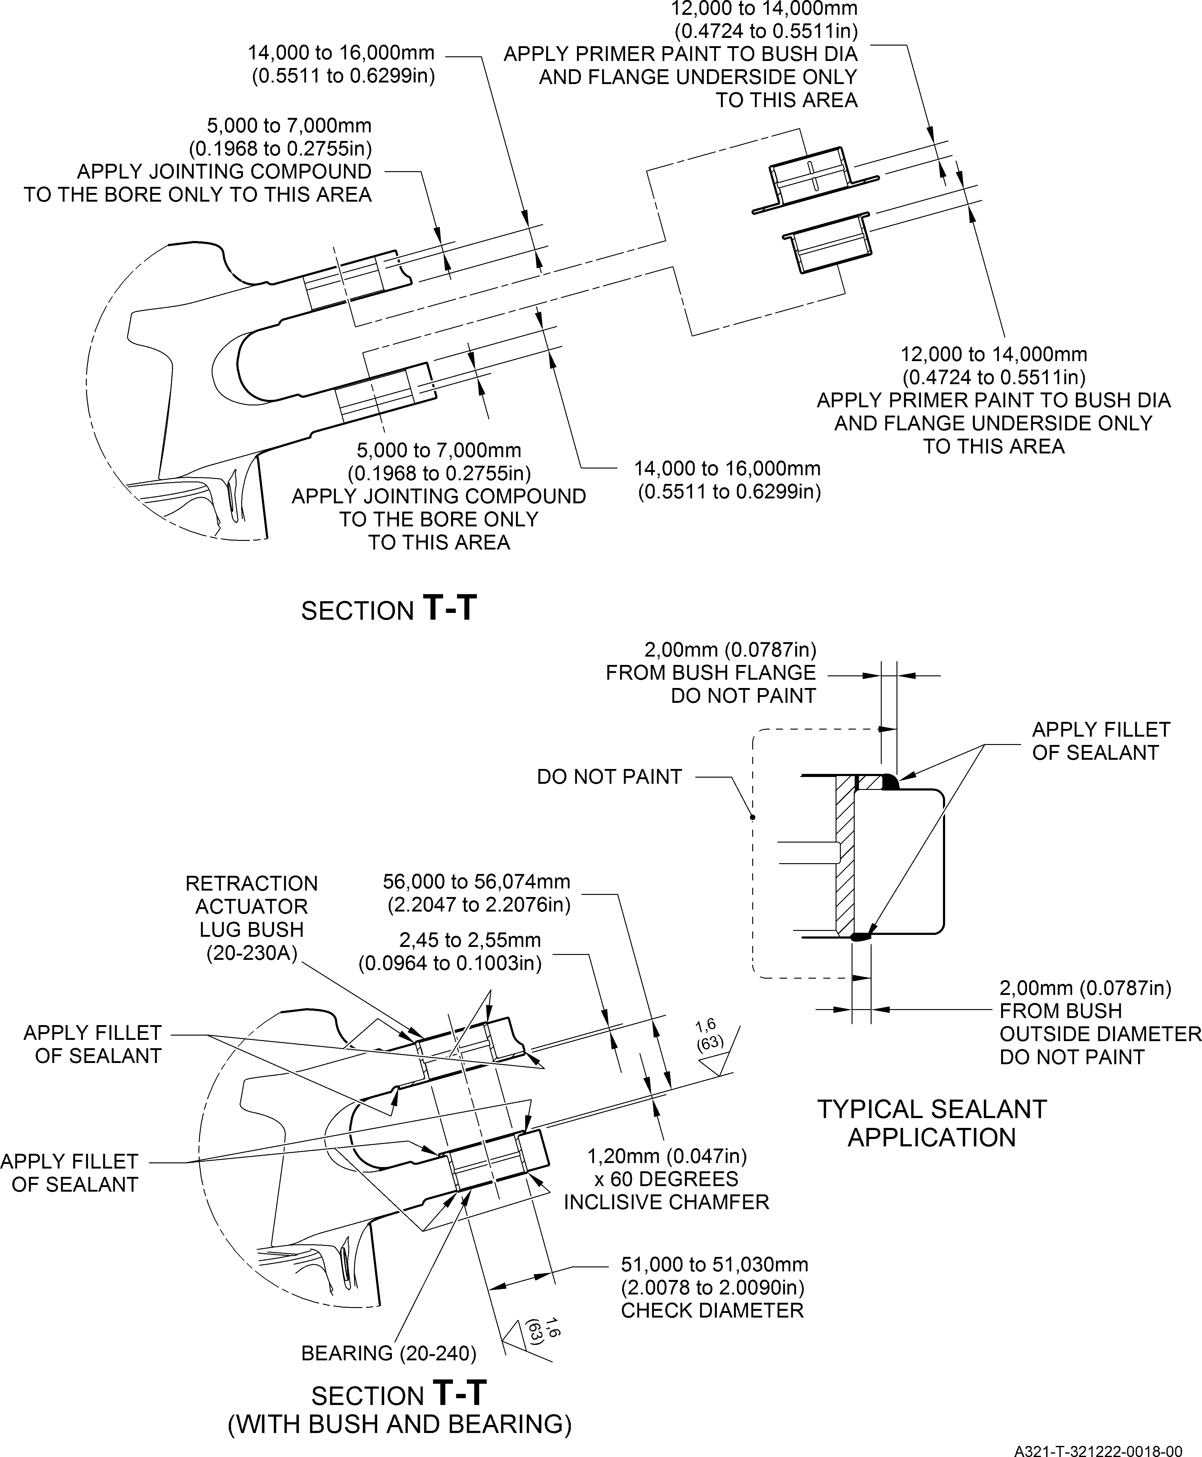

**SAFRAN LANDING SYSTEMS UK Ltd**

CAGE: K0654

PART No. 201587001 AND 201587002 COMPONENT MAINTENANCE MANUAL MAIN LANDING GEAR LEG

Main Fitting Subassembly (20-90B) or (20-90C) - Installation Figure 703 (Sheet 6 of 6)

32-12-22

Page 727 Sep 17/2021



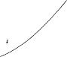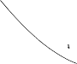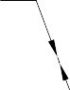

**SAFRAN LANDING SYSTEMS UK Ltd**

CAGE: K0654

PART No. 201587001 AND 201587002 COMPONENT MAINTENANCE MANUAL MAIN LANDING GEAR LEG

MAIN FITTING (20-410B OR 410C OR 410D)

LABEL TO BE IN LINE WITH LUG

LABEL (20-30D)

MESSIER-DOWTY gloucester

5,000 to 9,000mm

(0.1968 to 0.3543in)

**F**

**E**

**A**

LABEL (20-80)

DETAIL **B**

DETAIL **A**

10,50 to 14,50mm

(0.413 to 0.570in)

3,00 to 7,00mm

(0.118 to 0.275in)

**B**

**D**

(FOR LH ONLY)

LH LABEL (20-10)

RH LABEL (20-20)

DETAIL **E**

DETAIL **F**

17,000 to 21,000mm

**C** (FOR RH ONLY) 17,000 to 21,000mm

LABEL, RH (20-70)

(0.6692 to 0.8267in)

LABEL, LH (20-60)

(0.6692 to 0.8267in)

(FOR RH ONLY)

4,00 to 8,00mm

(0.157 to 0.315in)

22GA

4,00 to 8,00mm

(0.157 to 0.315in)

23GA

LABEL, RH (20-50)

144,00 to 148,00mm

(0.157 to 0.315in)

18,00 to 22,00mm

18,00 to 22,00mm

(0.708 to 0.866in)

LABEL, LH (20-40)

(0.708 to 0.866in)

DETAIL **D**

(FOR LH ONLY)

DETAIL **C**

A321-T-321222-0019-01

(FOR RH ONLY)

Installation of Labels Figure 704

32-12-22

Page 728 Sep 17/2021

20GA

17GA

21GA

GROUND



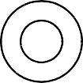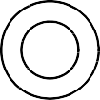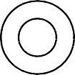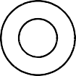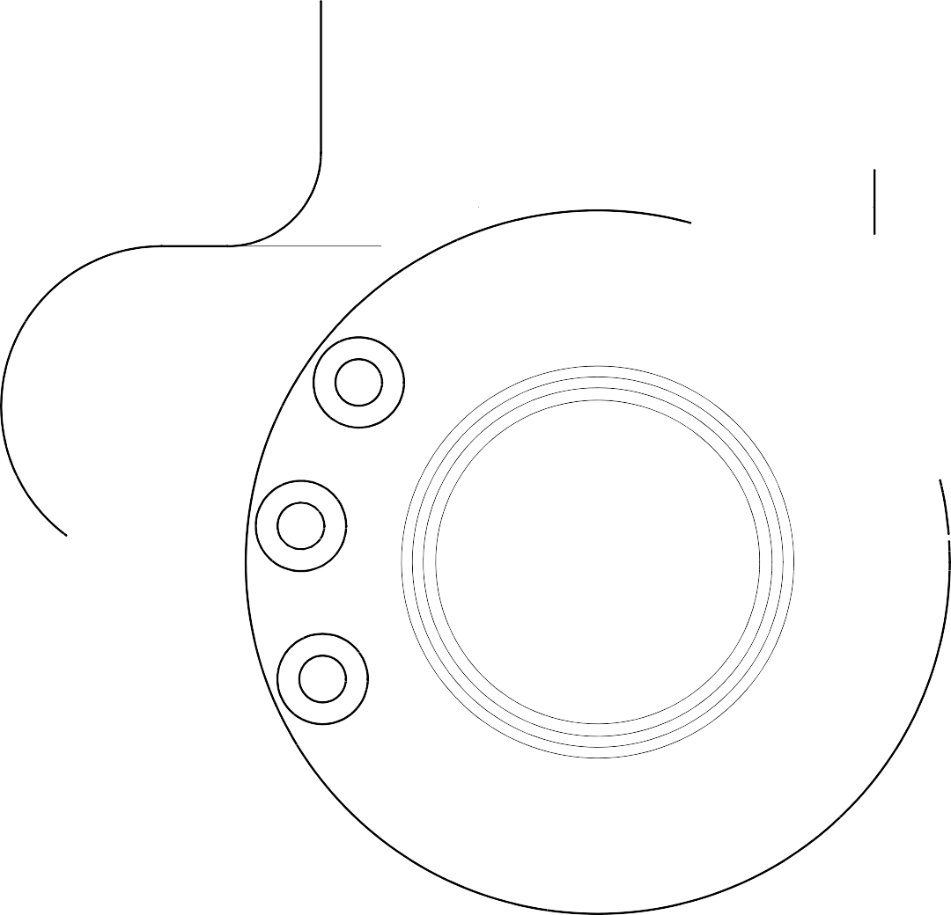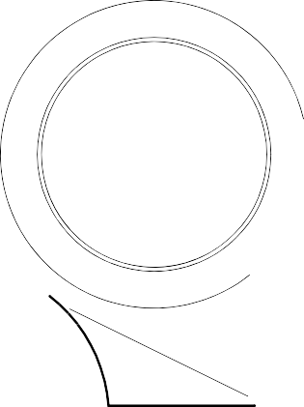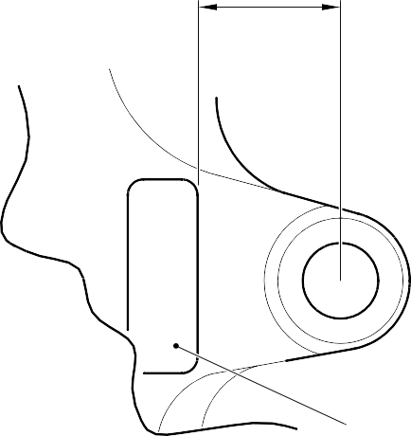

**SAFRAN LANDING SYSTEMS UK Ltd**

CAGE: K0654

PART No. 201587001 AND 201587002 COMPONENT MAINTENANCE MANUAL MAIN LANDING GEAR LEG

SLIDING TUBE

(18-80) OR (18-80A) OR (18-80D) OR (18-80E)

39,00 to 41,00mm

(1.536 to 1.614in)

LABEL (18-70)

A3219212-2

Label (18-70) - Installation Figure 705

32-12-22

Page 731 Mar 18/2025





**SAFRAN LANDING SYSTEMS UK Ltd**

CAGE: K0654

PART No. 201587001 AND 201587002 COMPONENT MAINTENANCE MANUAL MAIN LANDING GEAR LEG

SLIDING TUBE

(18-80) OR (18-80A) OR

(18-80D) OR (18-80E)

BUSH (18-50) ONLY

SLOT

6 DEGREES

LABEL (17-290) ONLY

A3219213-3

Label (17-290) Only and Bush (18-50) Only - Installation Figure 706

32-12-22

Page 732 Mar 18/2025



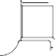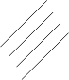

**SAFRAN LANDING SYSTEMS UK Ltd**

CAGE: K0654

PART No. 201587001 AND 201587002 COMPONENT MAINTENANCE MANUAL MAIN LANDING GEAR LEG

**Z**

**E**

(REFER TO **W**

(REFER TO SHEET 3)

SLIDING TUBE (18-80B) OR (18-80G)

SHEET 3)

**X**

**X**

(REFER TO SHEET 3)

135,000 to 135,500mm

(5.3150 to 5.3346in)

**Z**

APPLY PRIMER PAINT TO BUSH OUTER DIA. AND FLANGE UNDERSIDE ONLY TO THIS AREA

(TYPICAL 2 PLACES)

APPLY FILLET

(REFER TO SHEET 2)

OF SEALANT (TYPICAL 2 PLACES)

**Y**

22,000 to 22,033mm

(0.8661 to 0.8674in) CHECK DIAMETER (TYPICAL 2 PLACES)

BUSH (18-10)

(TYPICAL 2 PLACES)

2,5

(100)

**A**

SLIDING TUBE

(18-80B) OR (18-80G)

BUSH (18-50A)

60,000 to 60,030mm

(2.3621 to 2.3633in) CHECK DIAMETER

APPLY FILLET OF SEALANT (TYPICAL 2 PLACES)

-3 DEGREES TO +3 DEGREES SLOT ORIENTATION IMPORTANT

BUSH (18-40)

2,5

(100)

BUSH (18-40)

2,5

(100)

19,000 to 21,000mm

(0.7480 to 0.8267in)

(TYPICAL 2 PLACES)

APPLY PRIMER PAINT TO BUSH DIA AND FLANGE UNDERSIDE ONLY

TO THIS AREA (TYPICAL 2 BUSHES)

**B**

**C**

**Y**

APPLY JOINTING COMPOUND TO THE BORE ONLY TO THIS AREA

60,000 to 60,030mm

(2.3621 to 2.3633in) CHECK DIAMETER

5,000 to 7,000mm

(0.1968 to 0.2755in)

(TYPICAL 2 PLACES)

(TYPICAL 2 PLACES)

150,917 to 150,957mm

(5.9415 to 5.9431in)

SECTION **Z-Z**

0,040 mm

(0.0016 in)

**B**

A321-T-32-12-22-116-1

Sliding Tube Subassembly (17-240B or 17-240G) - Installation of Bushes Figure 707 (Sheet 1 of 5)

32-12-22

Page 737 Mar 18/2025

1,6

(63)

1,6

(63)

0,040 mm

(0.0016 in)

**C**

**W**



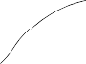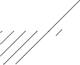

**SAFRAN LANDING SYSTEMS UK Ltd**

CAGE: K0654

PART No. 201587001 AND 201587002 COMPONENT MAINTENANCE MANUAL MAIN LANDING GEAR LEG

39,000 to 41,000mm

(1.5354 to 1.6141in)

LABEL (18-70)

VIEW **A**

82,870 to 83,410mm

(3.2625 to 3.2838in)

APPLY FILLET OF SEALANT

35,500 to 35,600mm

(1.3977 to 1.4015in) REF.

BUSH (18-50A)

APPLY PRIMER PAINT TO

BUSH OUTER DIA. AND FLANGE UNDERSIDE ONLY

TO THIS AREA

LABEL (17-290)

23 TO 27 DEGREES

SECTION **Y-Y**

A321-T-32-12-22-117-0

Sliding Tube Subassembly (17-240B or 17-240G) - Installation of Bushes Figure 707 (Sheet 2 of 5)

32-12-22

Page 738 Mar 18/2025

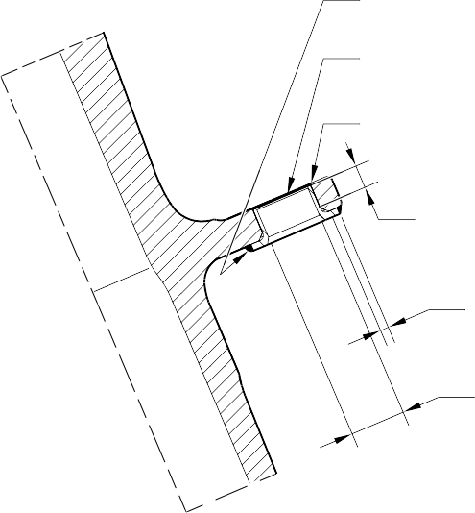

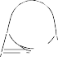

**SAFRAN LANDING SYSTEMS UK Ltd**

CAGE: K0654

PART No. 201587001 AND 201587002 COMPONENT MAINTENANCE MANUAL MAIN LANDING GEAR LEG

BUSH (18-30)

BUSH (18-20)

BUSH (18-30)

APPLY FILLET OF SEALANT

BUSH (18-20)

(TYPICAL 6 PLACES)

NO FILLET SEALANT AT THIS END

BUSH (18-20)

APPLY JOINTING COMPOUND TO THE BORE ONLY TO THIS AREA

APPLY PRIMER PAINT TO BUSH

FLANGE UNDERSIDE ONLY

16,8 to 17,2mm

(0.6614 to 0.6771in) REF. CHECK DIAMETER

BUSH (18-30)

BUSH (18-20)

BUSH

(18-30)

DETAIL **E**

1,000mm (0.0393in) FOR BUSHES (18-10),

(17-70) AND (18-30) 2,000mm (0.0787in)

FOR OTHER BUSHES DO NOT PAINT

MASK THE SEALANT

APPLY FILLET OF SEALANT

SECTION **W-W**

DO NOT PAINT

APPLY PAINT

NO FILLET SEALANT AT THIS END

BUSH (18-30)

(TYPICAL 18 PLACES)

APPLY JOINTING COMPOUND TO THE BORE ONLY TO THIS AREA

APPLY FILLET OF SEALANT

APPLY PRIMER PAINT TO BUSH UNDER SIDE FACE ONLY

APPLY FILLET OF SEALANT

2,000mm (0.0787in) FROM BUSH OUTSIDE DIAMETER DO NOT PAINT MASK THE SEALANT

15,000 to 15,027mm

(0.5905 to 0.5916in) CHECK DIAMETER

TYPICAL SEALANT APPLICATION

SECTION **X-X**

A321-T-32-12-22-118-0

Sliding Tube Subassembly (17-240B or 17-240C or 17-240F or 17-240G) - Installation of Bushes Figure 707 (Sheet 3 of 5)

32-12-22

Page 739 Mar 18/2025

2,5

(100)



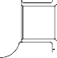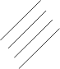

**SAFRAN LANDING SYSTEMS UK Ltd**

CAGE: K0654

PART No. 201587001 AND 201587002 COMPONENT MAINTENANCE MANUAL MAIN LANDING GEAR LEG

**Z**

(REFER TO SHEET 3)

**E**

(REFER TO SHEET 3)

**W**

SLIDING TUBE (18-80C) OR (18-80F)

**X**

**W**

**X**

(REFER TO SHEET 3)

134,980 to 135,344mm

(5.3142 to 5.3248in)

**Z**

APPLY PRIMER PAINT TO BUSH OUTER DIA. AND FLANGE UNDERSIDE ONLY TO THIS AREA

(TYPICAL 2 PLACES)

APPLY FILLET

(REFER TO SHEET 2)

OF SEALANT (TYPICAL 2 PLACES)

**Y**

22,000 to 22,033mm

(0.8661 to 0.8674in) CHECK DIAMETER (TYPICAL 2 PLACES)

BUSH (18-10)

(TYPICAL 2 PLACES)

2,5

(100)

**A**

SLIDING TUBE

(18-80C) OR (18-80F)

BUSH (18-50A)

60,000 to 60,030mm

(2.3621 to 2.3633in) CHECK DIAMETER

APPLY FILLET OF SEALANT (TYPICAL 2 PLACES)

-3 DEGREES TO +3 DEGREES SLOT ORIENTATION IMPORTANT

BUSH (18-40)

2,5

(100)

BUSH (18-40)

2,5

(100)

19,000 to 21,000mm

(0.7480 to 0.8267in)

(TYPICAL 2 PLACES)

APPLY PRIMER PAINT TO BUSH DIA AND FLANGE UNDERSIDE ONLY

TO THIS AREA (TYPICAL 2 BUSHES)

**B**

**C**

**Y**

APPLY JOINTING COMPOUND TO THE BORE ONLY TO THIS AREA

60,000 to 60,030mm

(2.3621 to 2.3633in) CHECK DIAMETER

5,000 to 7,000mm

(0.1968 to 0.2755in)

(TYPICAL 2 PLACES)

(TYPICAL 2 PLACES)

150,917 to 150,957mm

(5.9415 to 5.9431in)

SECTION **Z-Z**

0,040 mm

(0.0016 in)

**B**

A321-T-32-12-22-122-1

Sliding Tube Subassembly (17-240C or 17-240F) - Installation of Bushes Figure 707 (Sheet 4 of 5)

32-12-22

Page 740 Mar 18/2025

1,6

(63)

1,6

(63)

0,040 mm

(0.0016 in)

**C**



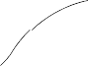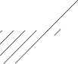

**SAFRAN LANDING SYSTEMS UK Ltd**

CAGE: K0654

PART No. 201587001 AND 201587002 COMPONENT MAINTENANCE MANUAL MAIN LANDING GEAR LEG

39,000 to 41,000mm

(1.5354 to 1.6141in)

LABEL (18-70)

VIEW **A**

82,870 to 83,410mm

(3.2625 to 3.2838in)

APPLY FILLET OF SEALANT

35,400 to 35,600mm

(1.3937 to 1.4015in) REF.

BUSH (18-50A)

APPLY PRIMER PAINT TO

BUSH OUTER DIA. AND FLANGE UNDERSIDE ONLY

TO THIS AREA

SECTION **Y-Y**

A321-T-32-12-22-123-0

Sliding Tube Subassembly (17-240C or 17-240F) - Installation of Bushes Figure 707 (Sheet 5 of 5)

32-12-22

Page 741 Mar 18/2025

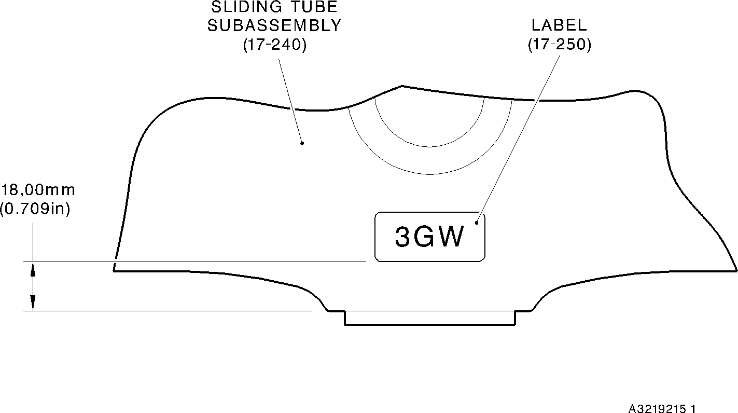



**SAFRAN LANDING SYSTEMS UK Ltd**

CAGE: K0654

PART No. 201587001 AND 201587002 COMPONENT MAINTENANCE MANUAL MAIN LANDING GEAR LEG

SLIDING TUBE

(18-80) OR (18-80A)

OR (18-80D) OR (18-80E)

BUSH (18-20)

BUSH (18-30)

9 PLACES

BUSH (18-20)

BUSH (18-20)

A3219214-2

Bushes (18-20 and 18-30) - Installation

Figure 708

Label (17-250) - Installation Figure 709

32-12-22

Page 743 Mar 18/2025



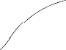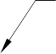

**SAFRAN LANDING SYSTEMS UK Ltd**

CAGE: K0654

PART No. 201587001 AND 201587002 COMPONENT MAINTENANCE MANUAL MAIN LANDING GEAR LEG

APPLY JOINTING COMPOUND TO

SLIDING TUBE (18-80B) OR

(18-80C) OR (18-80F) OR (18-80G)

SECTION **Y-Y**

**Y**

TOUCH UP PAINT EXTERNALLY ON LOCK WASHER AND JACKING DOME

CYLINDER (17-230A)

**Z**

**Z**

**Y**

JACKING DOME

LOCK WASHER (17-90A)

APPLY JOINTING COMPOUND TO

CYLINDER BORE

APPLY JOINTING COMPOUND TO CYLINDER

(FEMALE) THREAD DO NOT APPLY JOINTING COMPOUND TO JACKING DOME (MALE) THREAD

JACKING DOME (17-80A)

CHECK HOLES, SLOTS AND GROOVES ARE FREE FROM ANY GREASE

BUILD-UP TO MAKE SURE A CLEAR DRAINAGE PATH EXISTS

LABEL (17-290A)

6,000 to 8,000mm

(0.2363 to 0.3149in)

SLIDING TUBE SUB ASSEMBLY

(17-240B) OR (17-240C) OR (17-240F) OR (17-240G)

VIEW **A**

FOR SHOCK ABSORBER

SUBASSEMBLY (17-10J TO 17-10R)

23 to 27 DEGREES

LABEL

7,000 to 9,000mm

(0.2756 to 0.3543in)

(17-290) ONLY

**A**

PART SECTION **Z-Z**

VIEW **A**

FOR SHOCK ABSORBER

SUBASSEMBLY (17-10E TO 17-10H)

A321-T-32-12-22-119-2

Application of Jointing Compound Figure 710

32-12-22

Page 751 Mar 18/2025





**SAFRAN LANDING SYSTEMS UK Ltd**

CAGE: K0654

PART No. 201587001 AND 201587002 COMPONENT MAINTENANCE MANUAL MAIN LANDING GEAR LEG

LOWER BEARING

(16-150) OR (16A-150)

**B**

**Z**

65,0mm (2.56in)

DIA.

177,805 to 177,868mm

(7.0002 to 7.0026in) NO CADMIUM PLATE

**E**

1,6

(63)

LOWER BEARING SUBASSEMBLY (16-110) OR (16-110A) OR (16-110B) OR (16-110C) OR (16A-110) OR (16A-110A)

OR (16A-110B) OR (16A-110C)

GREASE GROOVES

**C**

**Z**

**A**

**NOTE: GLAND HOUSING (16-140) OR (16A-140) OR (16A-140A) NOT SHOWN FOR CLARITY**

RADIUS

0,4 to 1,0mm

(0.02 to 0.03in)

(3 PLACES)

4,0mm (0.15in)

**B**

DIA.

177,805 to 177,868mm

(7.0002 to 7.0026in)

**F**

**F**

RADIUS

3,5mm (0.13in)

DIA.

180,12 to 180,52mm

(7.092 to 7.107in)

0,20mm (0.007in)

**C**

DIA.

65,0mm (2.56in)

RADIUS

0,4 to 1,0mm

(0.02 to 0.03in) BLEND EDGES

DETAIL

SECTION **Z-Z**

**E**

RADIUS

0,4 to 1,0mm

(0.02 to 0.03in) BLEND EDGES

GREASE GROOVE

2x

RADIUS

3,5mm (0.13in)

to 1,10mm (0.036 to 0.043in)

RADIUS

0,4 to 1,0mm

(0.02 to 0.03in) BLEND EDGES

DETAIL **F**

A321-T-32-12-22-130-00

Pre SB 201-32-49 or Pre SB 201-32-58 or Pre SB 201-32-60 Lower Bearing (16-150) or (16A-150)

Grease Groove Dimensions After Installation in the Gland Housing (16-140) or (16A-140) or (16A-140A)

Figure 711

32-12-22

Page 752 Mar 18/2025

DIA. 4,0mm

(0.15in)

**A**

**D**

0,90

**D**





**SAFRAN LANDING SYSTEMS UK Ltd**

CAGE: K0654

PART No. 201587001 AND 201587002 COMPONENT MAINTENANCE MANUAL MAIN LANDING GEAR LEG

**Y**

**V**

**W**

**Z**

125 DEGREES (REF)

1

208,50 to 208,55mm (8.209 to 8.211in) DIA (REF)

SPLIT IN INNER LINER 201646300

SECTION **V-V**

**V**

LOWER BEARING SUBASSEMBLY 201587212

92,85 to 93,00mm

(3.655 to 3.661in)

**X**

64,650 to 64,775mm (2.5453 to 2.5502in)

**X**

DETAIL **Y**

0,5mm (0.020in) RAD

15

DEGREES

182,453 to 182,516mm (7.183 to 7.185in) DIA

178,87 to 179,07mm (7.042 to 7.050in) DIA

0,50mm (0.020in)

0,025mm (0.0010in)

**W**

0,04mm (0.0015in) DIA

**Z**

**X**

DETAIL

A321A6615-2

Post SB 201-32-58 - Lower Bearing Subassembly Machining and Liner Installation Figure 712 (Sheet 1 of 2)

32-12-22

Page 757 Mar 18/2025

25 DEGREES (REF)



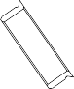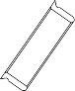

**SAFRAN LANDING SYSTEMS UK Ltd**

CAGE: K0654

PART No. 201587001 AND 201587002 COMPONENT MAINTENANCE MANUAL MAIN LANDING GEAR LEG

**Z**

APPLY PRIMER PAINT

**A**

DETAIL **A**

177,805 to 177,868mm (7.0002 to 7.0026in) DIA. REF.

208,50 to 208,55mm (8.209 to 8.210in) DIA. REF.

**Z**

LOWER BEARING SUBASSEMBLY

26,000 to 26,021mm

(1.0236 to 1.0244in)

(TYPICAL 3 PLACES)

0,50mm (0.019in)

x 45 DEGREES CHAMFER (TYPICAL 3 PLACES)

0,50mm (0.019in) x 45 DEGREES CHAMFER (TYPICAL 3 PLACES)

125 DEGREES (REF)

125 DEGREES (REF)

27,000 to 27,084mm

(1.0629 to 1.0662in)

REF DIAMETER

(TYPICAL 3 PLACES)

BUSH (16-130 OR 16A-130) (TYPICAL 3 PLACES)

LUBRICATE WITH GREASE

(3 PLACES)

SECTION **Z-Z**

Assembly of Lower Bearing Subassembly (16A-110C) Figure 712 (Sheet 2 of 2)

A321-T-32-12-22-120-0

32-12-22

Page 758 Mar 18/2025

1,6

(63)



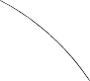

**SAFRAN LANDING SYSTEMS UK Ltd**

CAGE: K0654

PART No. 201587001 AND 201587002 COMPONENT MAINTENANCE MANUAL MAIN LANDING GEAR LEG

**Z**

**Y**

**Z**

26,000 to 26,021mm

(1.0237 to 1.0244in)

(3 PLACES)

208,50 to 208,55mm

(8.209 to 8.210in) DIA. (4 POSITIONS)

**Y**

SECTION **Z-Z**

125 DEGREES

125 DEGREES

COMMON LOWER BEARING BUSH (16-130A) OR (16A-130B) (3 PLACES)

LOWER BEARING HOUSING (16-140B) OR (16A-140C)

SECTION **Y-Y**

Assembly of Lower Bearing Subassembly (16-110D or 16A-110E) Figure 713

A321-T-32-12-22-108-0

32-12-22

Page 759 Mar 18/2025

2,5

(100)

0,050mm (0.0019in) DIA. M

**A**

**A**





**SAFRAN LANDING SYSTEMS UK Ltd**

CAGE: K0654

PART No. 201587001 AND 201587002 COMPONENT MAINTENANCE MANUAL MAIN LANDING GEAR LEG

NUT SUBASSEMBLY (17-130)

WASHER (17-170)

O-RING SEAL (17-210)

BACKING RING (17-220)

BEARING (17-180)

PISTON (17-200)

SEAL (17-190)

BACKING RING (16-30)

O-RING (16-20)

SEAL (16-60)

SEAL (16-70)

SEALING RING (16-90)

JOINT SEAL (16-80)

LOWER BEARING SUBASSEMBLY

APPLY LAYER OF SEALANT TO PCS-7200

WIPER RING (16-100)

A321-S-32-12-22-090-0

Seal Configuration Figure 714 (Sheet 1 of 2)

32-12-22

Page 760 Mar 18/2025

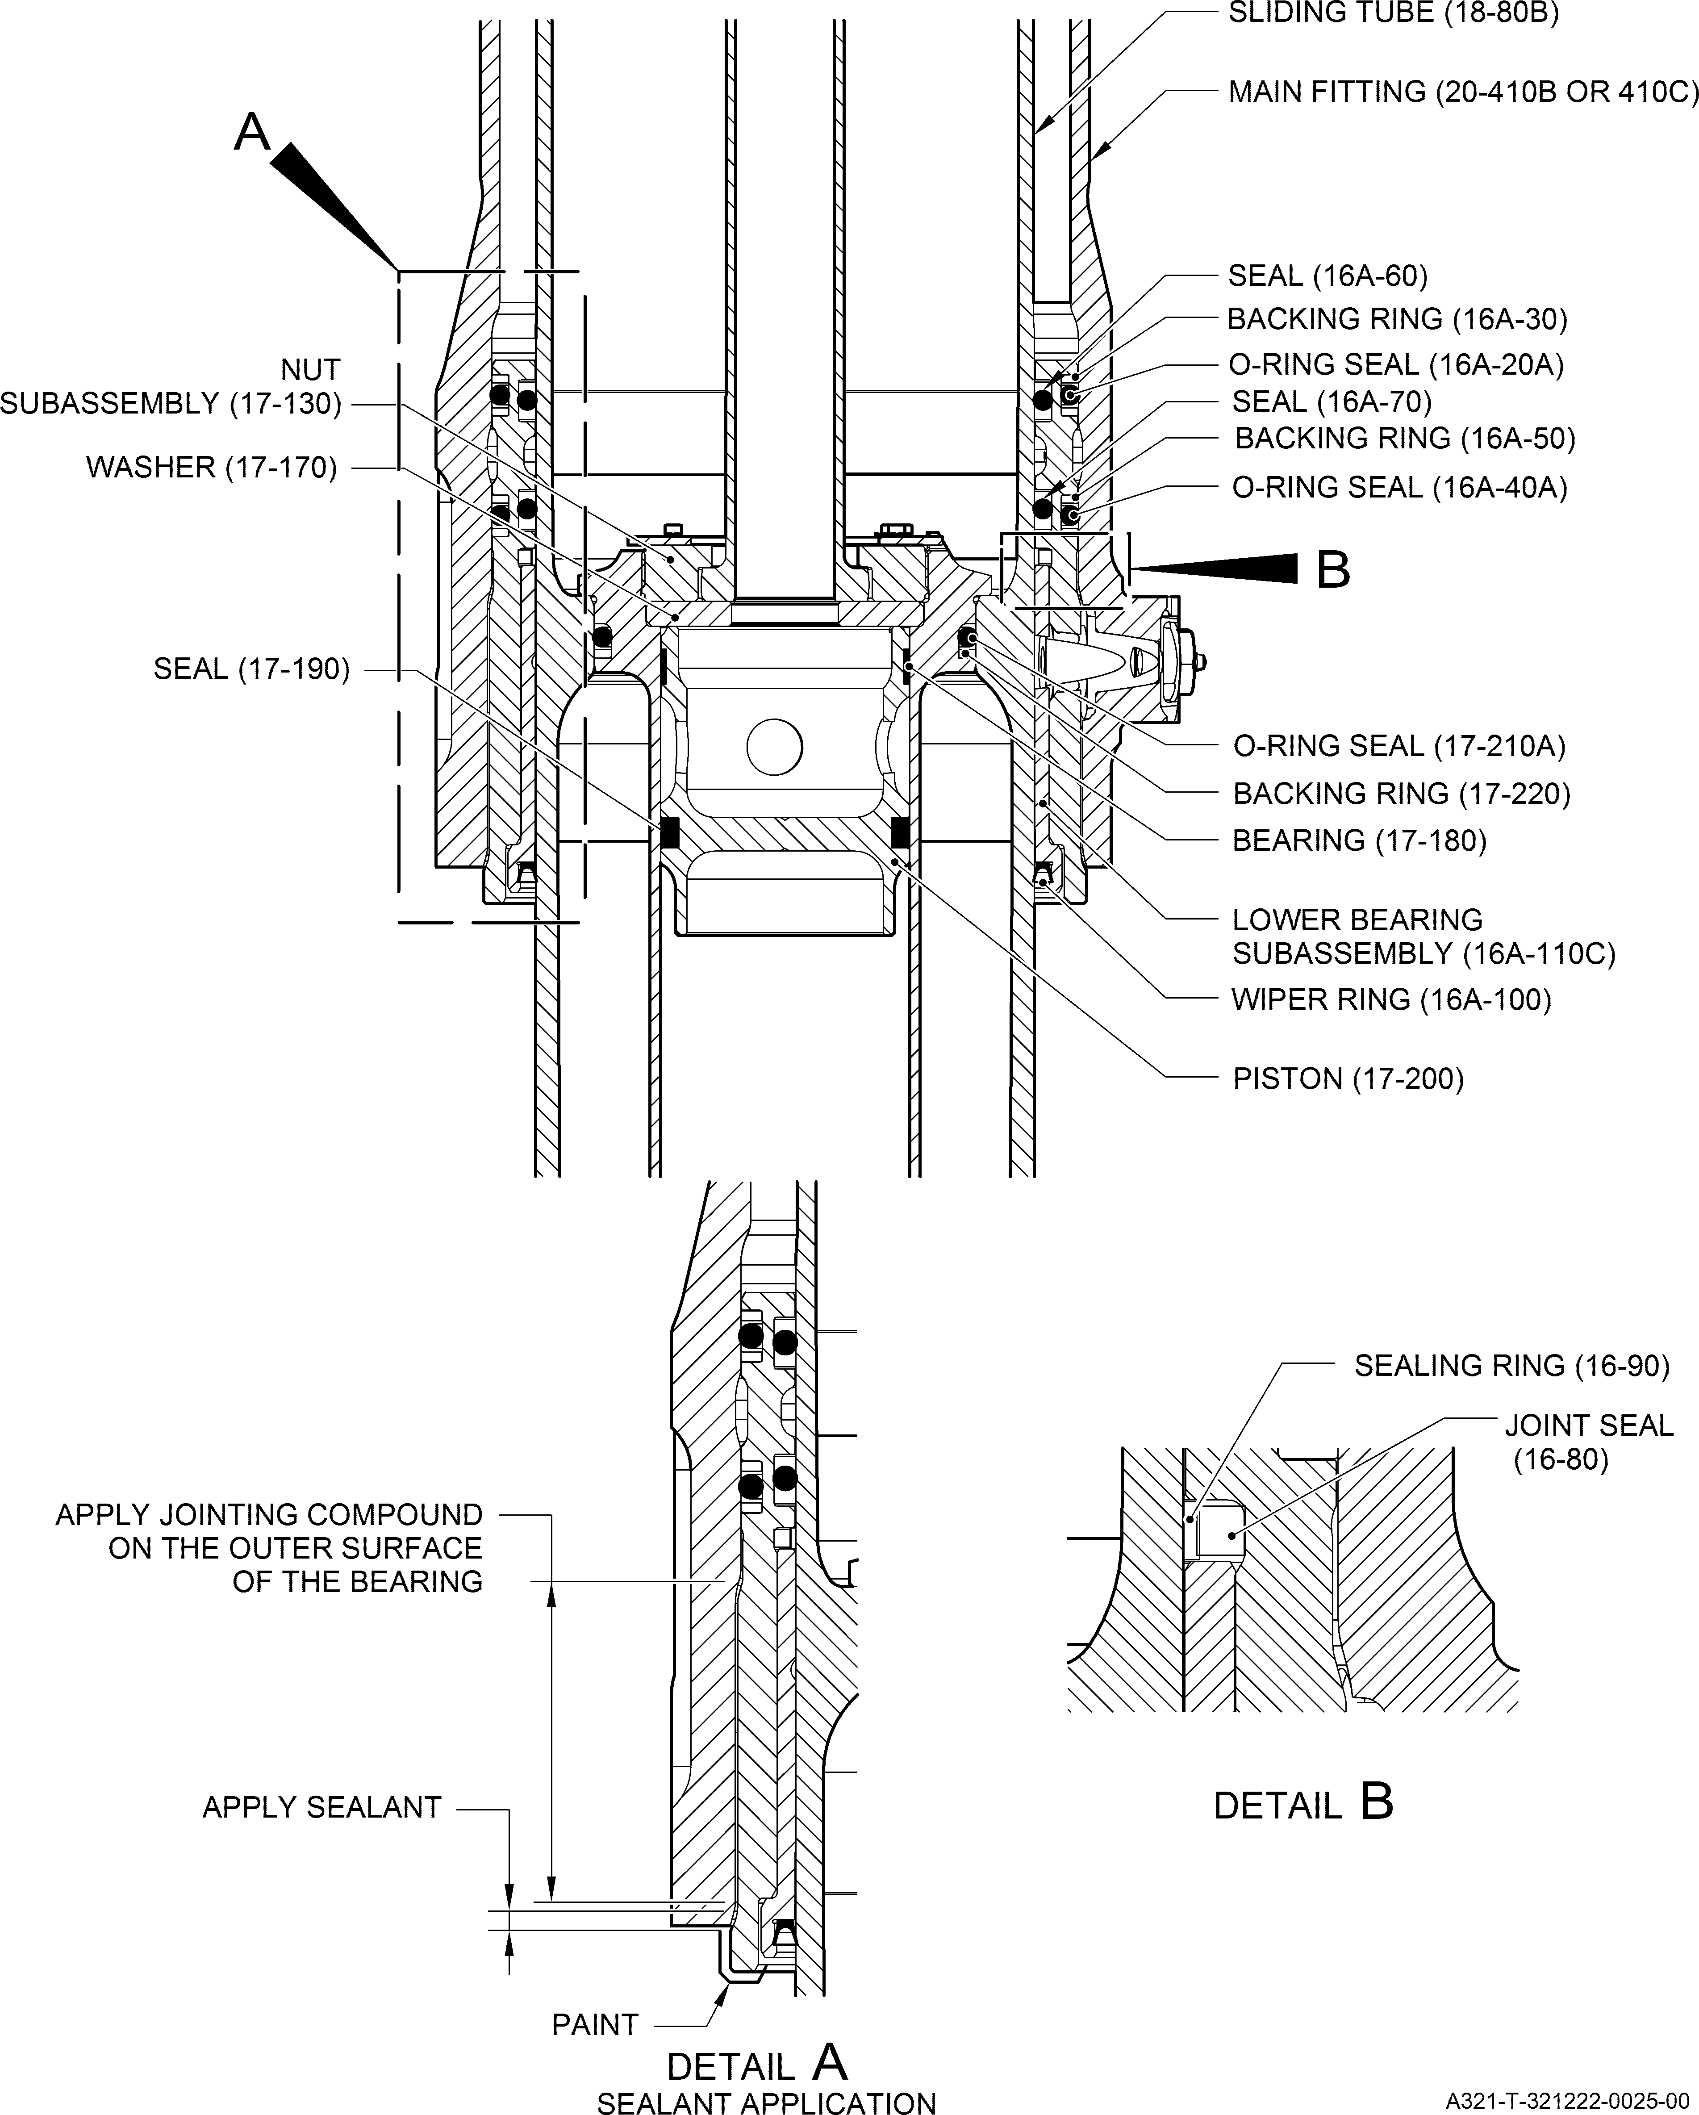

**SAFRAN LANDING SYSTEMS UK Ltd**

CAGE: K0654

PART No. 201587001 AND 201587002 COMPONENT MAINTENANCE MANUAL MAIN LANDING GEAR LEG

Seal Configuration Figure 714 (Sheet 2 of 2)

32-12-22

Page 761 Mar 18/2025





**SAFRAN LANDING SYSTEMS UK Ltd**

CAGE: K0654

PART No. 201587001 AND 201587002 COMPONENT MAINTENANCE MANUAL MAIN LANDING GEAR LEG

A

BUSH (15-370)

BUSH (15-380)

DATUM

B

DATUM

B

UPPER DIAPHRAGM TUBE (15-390)

A3219217-2

Upper Diaphragm Tube Subassembly (15-360 only) Figure 715

32-12-22

Page 768 Mar 18/2025

CONFIGURATION OF SEAL (15-290)